DESIGN AND IMPLEMENTATION OF AN INTELLIGENT DYNAMIC ACADEMIC TIMETABLE MANAGEMENT SYSTEM USING GENETIC ALGORITHM AND MICROSERVICES ARCHITECTURE
A CASE STUDY OF KAMPALA INTERNATIONAL UNIVERSITY IN TANZANIA

YUNUS SIRAJU MWANGA
BCS/30121/2301/DT

Research Project Submitted in Partial Fulfillment for the Degree in Bachelor of Information Technology At Kampala International University In Tanzania
June, 2025

DECLARATION

a) This project is my original work and has not been presented for a degree in any other University or for any other award.
Student’s Name: YUNUS SIRAJU MWANGA
Sign ___________________________ Date ___________________________

b) I confirm that the work reported in this project was carried out by the candidate under my supervision.
Name: MITAKI EVANS
Sign ___________________________ Date ___________________________

DEDICATION

Grateful to God for blessing and strength, my parents Mr. and Mrs. Mwanga for their support, and Kampala International University for enabling my academic journey and research.

ACKNOWLEDGEMENT
I would like to express my sincere and heartfelt gratitude to my supervisor, Mr. Evance, for his invaluable guidance, patience, and continuous encouragement throughout the development of this research. His constructive feedback and professional advice contributed to the success of this work.
I would also like to extend my appreciation to the lecturers and academic staff of Kampala International University in Tanzania (KIUT) for their dedication to teaching and for equipping me with the knowledge and skills that made this research possible.
My deepest gratitude goes to my beloved parents and my younger brother for their unconditional love, encouragement, patience, and moral support throughout my academic journey. Their sacrifices, prayers, and constant motivation gave me the strength to overcome challenges and remain focused on achieving my goals.
Finally, I extend my appreciation to all friends, colleagues, and everyone who contributed directly or indirectly to the successful completion of this research.

ABSTRACT
The manual preparation of academic timetables at universities such as Kampala International University in Tanzania (KIUT) remains time-consuming, error-prone, and unable to handle complex constraints and dynamic changes. This study designed and implemented Shedulex, an intelligent dynamic academic timetable management system using Genetic Algorithm optimization and microservices architecture. The general objective was to design and implement the system for KIUT. Specific objectives were to analyze existing manual processes, design a microservices architecture with UML modelling, implement a GA engine for hard and soft constraint satisfaction, develop an AI-assisted adjustment module for dynamic rescheduling, and integrate document export and SMS/email notification services. The study employed Design Science Research supported by descriptive surveys and interviews with KIUT academic staff. The system was developed using Agile methodology with Scrum, implemented as eight Flask microservices behind a Kong API gateway, with PostgreSQL per-service databases, Redis for caching and Celery task queuing, and a Vue 3 frontend. Testing confirmed that the GA engine generated conflict-free timetables within minutes, achieved high soft-constraint satisfaction, and that the LangGraph-based Sora assistant supported lecturer substitution and conflict resolution. The study recommends adoption at KIUT and extension to other Tanzanian higher education institutions.

TABLE OF CONTENTS

DECLARATION ii
DEDICATION iii
ACKNOWLEDGEMENT iv
ABSTRACT v
LIST OF TABLES ix
LIST OF FIGURES xi
LIST OF ACRONYMS AND ABBREVIATIONS xii
DEFINITION OF KEY TERMS xiii
CHAPTER ONE: INTRODUCTION 1
1.1 Introduction 1
1.2 Background of the Study 1
1.3 Problem Statement 3
1.4 Objectives of Study 3
1.4.1 General Objective 3
1.4.2 Specific Objectives 3
1.5 Research Questions 3
1.6 Significance of the Study 4
1.7 Limitations of the Study 4
1.8 Scope of the Study 4
1.9 Organization of the Study 5
CHAPTER TWO: LITERATURE REVIEW 6
2.1 Introduction 6
2.2 Theoretical Literature of the problem 6
2.3 Similar Systems 6
2.4 Critical Review and Research Gap identification 12
2.5 Chapter Summary 12
CHAPTER THREE: METHODOLOGY 14
3.1 Introduction 14
3.2 Research Design 14
3.2.1 Target population 14
3.2.2 Sample size 15
3.2.3 Data collection procedure & instruments 16
3.3 System Development methodology 16
3.3.1 Methodology Justification 16
3.4 System Requirement Analysis 18
3.4.1 Functional requirements 18
3.4.2 Non-functional requirements 18
3.4.3 Modeling Language 19
3.5 Database Design 23
3.5.1 Table Design 23
3.5.2 3NF Normalized form 34
3.6 Testing Design 39
3.6.1 Test cases 39
3.7 Chapter Summary 40
CHAPTER FOUR: RESEARCH FINDINGS AND DISCUSSION 42
4.1 Introduction 42
4.2 Presentation of Findings 42
4.2.1 Objective (i): Design of Shedulex System Architecture 42
4.2.2 Objective (ii): Development and Implementation of Genetic Algorithm Timetable Generation Engine 44
4.2.3 Objective (iii): AI-Assisted Timetable Adjustment Module (Sora) with Document Generation and Notifications 46
4.3 Usability Evaluation 49
4.4 Chapter Summary 49
CHAPTER FIVE: SUMMARY, CONCLUSIONS AND RECOMMENDATIONS 51
5.1 Introduction 51
5.2 Summary of Findings 51
5.2.1 Objective (i) 51
5.2.2 Objective (ii) 51
5.2.3 Objective (iii) 51
5.3 Conclusions 51
5.4 Recommendations 52
5.5 Suggestions for Further Study 52
5.6 Chapter Summary 52
REFERENCES 54
APPENDICES 56
Appendix A: Questionnaire Sample Items 56
Appendix B: Microservices Port Reference 56
Appendix C: Program Code Reference 56

LIST OF TABLES
Table 1Sample Size Distribution 15
Table 2 Non-functional requirements 18
Table 3 Microservice databases 23
Table 4 auth_db Tables 23
Table 5 timetable_db Tables (Core Scheduling) 24
Table 6 Supporting Service Tables 24
Table 7 Mapping: Old Design → Shedulex (Corrections) 25
Table 8 roles Table 25
Table 9 users Table 26
Table 10 user_sessions Table 26
Table 11 universities Table 27
Table 12 departments Table 27
Table 13 programs Table 27
Table 14 courses Table 28
Table 15 lecturers Table 28
Table 16 rooms Table 29
Table 17 time_slots Table 29
Table 18 constraints Table 30
Table 19 timetables Table 30
Table 20 timetable_entries Table 31
Table 21 audit_logs Table 31
Table 22 course_student_groups 32
Table 23 lecturer_programs 32
Table 24 course_group_lecturers 32
Table 25 First Normal Form Violation 34
Table 26 First Normal Form Correction 34
Table 27 Second Normal Form violation 35
Table 28 Second Normal Form correction (Table : Courses ) 35
Table 29 Second Normal Form correction (Table : Lectures ) 36
Table 30 Second Normal Form correction (Table : Rooms ) 36
Table 31 Second Normal Form correction (Table : timetable entries ) 36
Table 32 Third Normal Form Violation 37
Table 33 Third Normal Form Correction (Table: universities) 37
Table 34 Third Normal Form Correction (Table: departments) 37
Table 35 Third Normal Form Correction (Table: programs) 37
Table 36 Third Normal Form Correction (Table: student_groups) 38
Table 37 Third Normal Form Correction (Table: rooms) 38
Table 38 Third Normal Form Correction (Table: time_slots) 38
Table 39 Test cases 39
Table 40 GA Performance Results (Averaged over 10 runs) 44
Table 41 Results summary 49

LIST OF FIGURES
Figure 1 UniTime Timetable Interface 7
Figure 2 Untis Timetable Interface 8
Figure 3 aSc Timetable System Interface 9
Figure 4 CELCAT Timetable System Interface 10
Figure 5 Creatrix Campus AI Timetable Interface 11
Figure 6 Use case Diagram 19
Figure 7 Activity Diagram 20
Figure 8 Sequence Diagram 21
Figure 9 Deployment Diagram 22
Figure 10 Entity Relationship Summary Diagram 33
Figure 11 Shedulex Login Interface – Demonstrating secure authentication with JWT tokens validated by Kong gateway. 43
Figure 12 Docker Desktop Containers View for the Shedulex Microservices Architecture 43
Figure 13 Resource Management Interface CRUD operations for Lecturer-Course Assignments 45
Figure 14 Timetable Generation Page – Real-time GA progress monitoring and final weekly timetable grid view. 45
Figure 15 Sora AI Chat Interface – Natural language interaction and detailed tool execution trace for dynamic adjustment. 46
Figure 16 Document Export Functionality – PDF and Excel generation with professional formatting and branding. 47
Figure 17 Notification Management Interface for Sending Notifications 47
Figure 18 Notification Management – Bulk SMS and email delivery status with delivery reports. 48
Figure 19 Timetable Preview, export and management Interface 48

LIST OF ACRONYMS AND ABBREVIATIONS

GA – Genetic Algorithm
UCTP – University Course Timetabling Problem
KIUT – Kampala International University in Tanzania
SMS – Short Message Service
UML – Unified Modelling Language
API – Application Programming Interface
AI – Artificial Intelligence
DB – Database
JWT – JSON Web Token
RBAC – Role-Based Access Control
ORM – Object-Relational Mapping
DSR – Design Science Research
SSE – Server-Sent Events
CRUD – Create, Read, Update, Delete
KPI – Key Performance Indicator

DEFINITION OF KEY TERMS
Genetic Algorithm
A population-based metaheuristic optimization technique inspired by natural evolution, used here to search for optimal timetable solutions under multiple constraints.
Microservices Architecture
A design style where a large application is built as a collection of small, independent, loosely coupled services that communicate via APIs and Messaging Ques.
Intelligent Dynamic Scheduling
The system’s ability to detect changes (e.g., lecturer unavailability, venue unavailability) in real time, re-optimize the timetable, and automatically assign qualified replacements.
Hard Constraints
Mandatory scheduling rules that must not be violated, such as preventing double-booking of lecturers, rooms, or student groups.
Soft Constraints
Desirable scheduling preferences weighted in the fitness function, such as even lecture distribution and minimising gaps in student timetables.
Timetable Officer
An institutional user role responsible for managing academic resources, generating timetables, and approving schedule changes.

CHAPTER ONE: INTRODUCTION

1.1 Introduction
Academic timetable management is an essential administrative activity in universities and other higher learning institutions. It involves allocating courses, lecturers, venues, and time slots in a structured manner that ensures efficient utilization of available academic resources. A well-organized timetable ensures that students attend classes without conflicts, lecturers manage teaching responsibilities effectively, and institutional resources such as classrooms and laboratories are optimally utilized.
In modern universities, timetable generation has become increasingly complex due to growing student enrollment, expansion of academic programs, diverse lecturer availability, and limited teaching facilities. Universities must coordinate operational constraints including lecturer preferences, room capacities, course requirements, and institutional policies such as lunch breaks. When these factors are not properly coordinated, timetable conflicts disrupt academic activities and reduce institutional efficiency.
Traditionally, many universities rely on manual or semi-manual methods using spreadsheets or paper records. While these approaches may work for small institutions, they become inefficient and error-prone in large universities with multiple departments and programs. To address these challenges, researchers have explored intelligent scheduling approaches using computational algorithms. Among these, Genetic Algorithms (GAs) have gained significant attention due to their ability to handle complex constraint-based scheduling problems.
This study designed and implemented Shedulex, an Intelligent Dynamic Academic Timetable Management System for Kampala International University in Tanzania (KIUT). The system automates timetable generation using a Genetic Algorithm, minimizes scheduling conflicts, and incorporates an AI assistant (Sora) for dynamic rescheduling when disruptions such as lecturer absence or venue unavailability occur.

1.2 Background of the Study
Efficient academic timetable management is critical for ensuring the smooth operation of higher education institutions. Universities must coordinate numerous academic activities, including course delivery, lecturer schedules, classroom allocation, and student attendance, within a limited number of time slots and physical resources. As universities expand their academic programs and student populations, managing these schedules becomes increasingly challenging.
At Kampala International University in Tanzania (KIUT) and many similar institutions, the process of creating academic timetables is still largely performed manually using spreadsheets or traditional scheduling approaches. These methods require administrators to manually assign courses to time slots and venues while considering lecturer availability and institutional policies. However, as the number of students, courses, and lecturers increases, manual scheduling becomes highly complex and prone to errors.
Several operational constraints contribute to this complexity. Universities must ensure that a lecturer is not scheduled to teach multiple classes at the same time, that classrooms are not double-booked, and that room capacities match the number of students enrolled in each course. Additionally, scheduling must respect institutional policies such as mandatory breaks, lunch periods, and departmental scheduling preferences. When these constraints are not carefully managed, timetable conflicts occur, which disrupt academic activities and reduce institutional efficiency.
Studies in academic scheduling have shown that the University Course Timetabling Problem (UCTP) is one of the most complex combinatorial optimization problems in operations research. According to Burke and Petrovic (2002), university timetabling involves assigning a set of events (such as lectures) to limited time slots and rooms while satisfying numerous constraints, making it computationally difficult to solve using traditional deterministic approaches. Similarly, Schaerf (1999) identifies academic timetabling as a highly constrained scheduling problem that requires advanced optimization techniques to produce feasible and efficient solutions.
The complexity of timetabling problems has led researchers to classify the problem as NP-hard, meaning that the number of possible scheduling combinations grows exponentially as the number of courses, rooms, and time slots increases (Carter & Laporte, 1996). Because of this complexity, many studies recommend the use of metaheuristic algorithms, such as Genetic Algorithms, Simulated Annealing, and Tabu Search, which are capable of exploring large solution spaces to identify near-optimal solutions within reasonable computation time.
In recent years, universities worldwide have begun adopting intelligent scheduling systems to automate timetable generation and reduce administrative workload. However, many commercial timetable management systems are expensive, lack customization for local institutional requirements, or do not support dynamic timetable adjustments when unexpected disruptions occur, such as lecturer absence or venue unavailability.

Furthermore, many existing systems do not integrate modern technologies such as microservices architecture, real-time notifications (SMS or email alerts), or automated document export, which are increasingly required for efficient academic administration. These limitations highlight the need for a more flexible and intelligent timetable management system tailored to the operational needs of universities like KIUT.
Therefore, this study aims to design and develop an Intelligent Dynamic Academic Timetable Management System that leverages Genetic Algorithms to generate optimized schedules while supporting dynamic adjustments and improved resource utilization within the university environment.

1.3 Problem Statement
Manual timetable creation at KIUT takes weeks, frequently results in clashes such as venue overlaps and lecturer double-booking, ignores lecturer preferences and free periods, and cannot adapt to emergencies such as sudden lecturer absence or venue unavailability. These issues cause lost instructional hours, student dissatisfaction, uneven workload distribution, and inefficient resource utilization. Existing commercial systems lack integrated intelligent re-scheduling, microservices scalability, bulk SMS reminders, and automated document export tailored to Tanzanian higher education needs. Authoritative studies confirm that the University Timetabling Problem is NP-hard and requires metaheuristic solutions such as Genetic Algorithms (Burke & Petrovic, 2002; Carter & Laporte, 1996).

1.4 Objectives of Study

1.4.1 General Objective
To design and implement an intelligent, dynamic academic timetable management system using Genetic Algorithm and Microservices Architecture for Kampala International University in Tanzania.

1.4.2 Specific Objectives
- To design the Shedulex system architecture using a microservices architecture, Kong API Gateway, and UML modelling techniques for scalable and modular timetable management.
- To develop and implement a Genetic Algorithm-based timetable generation engine that produces optimized class timetables while satisfying predefined hard and soft scheduling constraints.
- To develop and integrate an AI-assisted timetable adjustment module (Sora), together with PDF/Excel document generation and bulk SMS notification services, to support dynamic timetable rescheduling and automated communication.

1.5 Research Questions
- What system architecture and design approaches can be used to develop a scalable and modular Shedulex timetable management system using microservices, Kong API Gateway, and UML modelling techniques?
- How can a Genetic Algorithm be implemented to generate optimized university timetables that satisfy predefined hard and soft scheduling constraints?

- In what ways can an AI-assisted timetable adjustment module (Sora), integrated with PDF/Excel document generation and bulk SMS notification services, enhance dynamic timetable rescheduling and automated communication?

1.6 Significance of the Study
The system will benefit KIUT administrators by reducing timetable preparation time from weeks to minutes. Lecturers will receive automated reminders and fair workload distribution. Students will access conflict-free schedules. The university will achieve optimized venue utilization and auditable scheduling operations. The study will serve as a model for other Tanzanian institutions and demonstrate practical application of Genetic Algorithms, AI agents, and modern software architecture in solving real-world administrative problems.

1.7 Limitations of the Study
The study was limited to KIUT's academic programs and data availability from willing participants. External factors such as sudden policy changes by the university senate were beyond the researcher's control. Live SMS delivery depended on third-party gateway availability (Beem Africa API), and AI adjustment features required an OpenAI API key for full operation during testing.

1.8 Scope of the Study
This study focuses on the design and development of an Intelligent Dynamic Academic Timetable Management System for higher education institutions. The scope of the study is defined in terms of conceptual, content, geographical, and time dimensions.
Conceptual Scope:
The study focuses on the application of intelligent computational techniques for solving the university timetabling problem. It specifically explores the use of optimization methods such as Genetic Algorithms together with Artificial Intelligence (AI) agents to automate timetable generation and enable dynamic timetable adjustment when disruptions occur.
Content Scope:
The system developed in this study covers several key functional components including Automatic timetable generation, constraint management, dynamic AI rescheduling, document export (PDF, Excel, CSV), SMS/email notifications, academic calendar management, analytics, and audit logging.
Geographical scope: Kampala International University in Tanzania (Dar es Salaam campus).
Time scope: Academic year 2025/2026 data and implementation.

1.9 Organization of the Study
This research project is organized into five chapters, each addressing a specific aspect of the study from introduction to conclusions and recommendations.
Chapter One: Introduction
This chapter presents the general overview of the study. It introduces the research topic and explains the context of academic timetable management in higher education institutions. The chapter also presents the background of the study, the problem statement, objectives of the study, research questions, significance of the study, limitations of the study, and the scope of the study.
Chapter Two: Literature Review
This chapter reviews relevant theoretical and empirical literature related to academic timetable management and automated scheduling systems. It discusses the theoretical framework guiding the study, examines existing timetable management systems used in other institutions, and reviews optimization techniques such as Genetic Algorithms used in solving the university timetabling problem. The chapter also identifies the research gap that the proposed system intends to address.
Chapter Three: Methodology
This chapter explains the research methodology used in the study. It describes the research design, target population, sampling techniques, and data collection methods. The chapter also presents the system development methodology, system requirement analysis, and system modeling techniques such as use case diagrams, activity diagrams, sequence diagrams, and class diagrams. Additionally, the chapter describes the database design and testing approach used to evaluate the developed system.
Chapter Four: Research Findings and Discussion
This chapter presents the results obtained from the implementation and testing of the proposed system. It provides screenshots and demonstrations of the developed system modules such as login interfaces, data entry forms, timetable generation outputs, and system reports. The chapter also discusses how the developed system addresses the research objectives and improves the timetable management process.
Chapter Five: Summary, Conclusions and Recommendations
This chapter summarizes the key findings of the study and presents conclusions drawn from the research. It evaluates whether the objectives of the study were achieved and explains how the proposed system contributes to improving academic timetable management. The chapter also provides recommendations for improving the system and suggestions for further research in intelligent scheduling systems.

CHAPTER TWO: LITERATURE REVIEW

2.1 Introduction
This chapter reviews the theoretical foundations, existing technologies, and previous research related to academic timetable management systems. It examines scholarly literature on optimization techniques used to solve the University Course Timetabling Problem (UCTP) and discusses the architectural approaches used in modern software systems for scheduling applications. The review establishes the conceptual understanding necessary for designing an intelligent timetable management system.

Additionally, the chapter analyzes existing timetable management systems used in educational institutions worldwide. By examining their features, capabilities, and limitations, the study identifies gaps that justify the development of the proposed Intelligent Dynamic Academic Timetable Management System. The chapter concludes by highlighting the research gap that the proposed system aims to address.

2.2 Theoretical Literature of the problem
The University Course Timetabling Problem (UCTP) is a classic NP-hard combinatorial optimization problem involving allocation of courses, lecturers, students, and venues under numerous hard and soft constraints. Genetic Algorithms have proven highly effective because they evolve a population of candidate solutions through selection, crossover, and mutation until an optimal or near-optimal timetable emerges. Key concepts include chromosome representation (time-slot encoding), fitness function (penalty for constraint violations), and repair operators to maintain feasibility.
Microservices Architecture complements this by decomposing the system into independent services (timetable generation engine, notification service, document engine) that scale independently and communicate via REST APIs or message queues.

2.3 Similar Systems
Five similar systems were reviewed:

- UniTime (open-source): Constraint-based solver using integer programming; strong on conflict resolution but monolithic and lacks intelligent emergency replacement or bulk SMS.

Figure 1 UniTime Timetable Interface

- Untis (commercial): Popular in Europe; uses optimization algorithms and offers mobile access, but not microservices-based and limited dynamic re-scheduling.
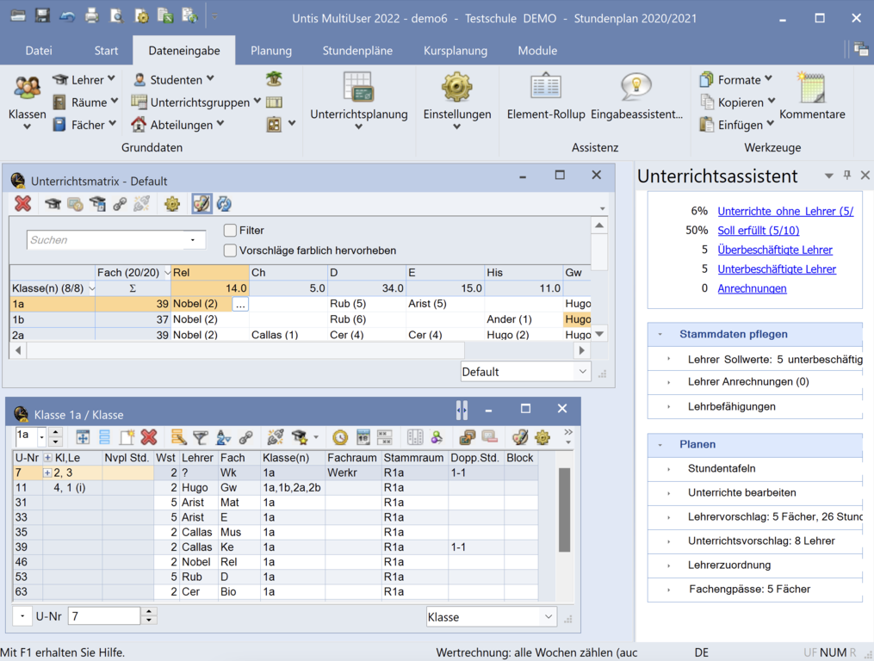
Figure 2 Untis Timetable Interface

- aSc Timetables: Excellent for schools; automatic generation with teacher preferences, but no GA implementation or intelligent agent for absences.
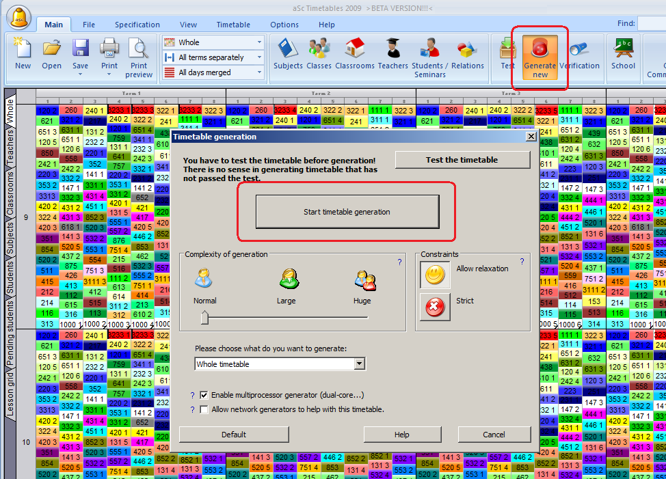
Figure 3 aSc Timetable System Interface

- CELCAT (HE-focused): Handles complex university constraints; includes reporting but remains monolithic and does not integrate bulk SMS or auto-replacement.
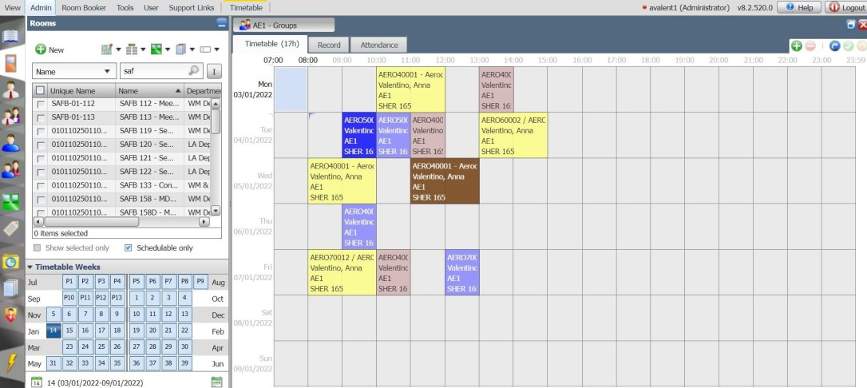
Figure 4 CELCAT Timetable System Interface

- Creatrix Campus AI Timetable: Uses AI slot allocation for conflict-free schedules; good workload balancing but lacks explicit GA optimization and microservices architecture.

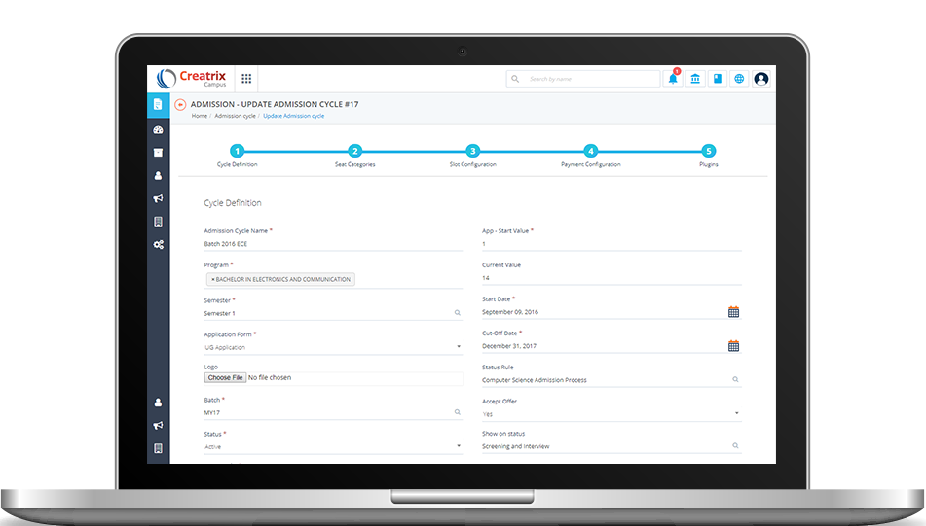
Figure 5 Creatrix Campus AI Timetable Interface

2.4 Critical Review and Research Gap identification
While existing systems address basic generation, none integrate Genetic Algorithm optimization with a complete microservices architecture, an AI assistant for automatic lecturer substitution and constraint re-evaluation, Celery-based notification queuing, and seamless PDF/Excel/CSV export behind a centralized API gateway. Shedulex fills this gap by providing a scalable, intelligent, and locally relevant solution implemented as eight Flask microservices (auth, timetable, adjustment, notification, calendar, document, analytics, audit) orchestrated through Docker Compose with Kong gateway, PostgreSQL, Redis, and ChromaDB.

2.5 Chapter Summary
This chapter reviewed the theoretical and practical foundations relevant to the development of an Intelligent Dynamic Academic Timetable Management System. The discussion began by examining the University Course Timetabling Problem (UCTP), which is recognized as a complex combinatorial optimization problem in the field of operations research and computer science. The literature shows that generating an academic timetable requires balancing multiple constraints such as lecturer availability, classroom capacity, course requirements, and time-slot limitations. Because these constraints interact in complex ways, the timetabling problem is classified as NP-hard, meaning that obtaining an optimal solution through traditional exhaustive methods becomes computationally impractical for large institutions.
To address this complexity, the chapter explored the role of Genetic Algorithms (GAs) as an effective optimization technique for timetable generation. Genetic Algorithms mimic the process of natural evolution by iteratively improving candidate solutions through mechanisms such as selection, crossover, and mutation. The literature demonstrates that GA-based approaches are capable of producing high-quality timetables by minimizing constraint violations and optimizing resource allocation. Key concepts discussed include chromosome representation for encoding timetable slots, fitness functions used to evaluate solution quality, and repair mechanisms that ensure generated timetables remain feasible. These characteristics make Genetic Algorithms a suitable approach for solving dynamic scheduling problems in educational environments.
In addition to optimization techniques, the chapter also reviewed Microservices Architecture as a modern software design approach suitable for complex systems. Microservices allow large applications to be divided into smaller, independent services that communicate through well-defined APIs. This architectural approach improves scalability, maintainability, and system reliability compared to traditional monolithic systems. For an academic timetable management system, microservices enable the separation of critical functionalities such as timetable generation, notification services, user management, and document export services. This modular structure ensures that system components can evolve independently and scale according to institutional demands.
Furthermore, the chapter analyzed several existing timetable management systems, including UniTime, Untis, aSc Timetables, CELCAT, and Creatrix Campus AI Timetable. Each of these systems demonstrates significant capabilities in automated timetable generation and constraint management. However, the analysis revealed several limitations when compared to the requirements of modern universities, particularly in the context of developing regions such as Tanzania. Most of the reviewed systems operate using monolithic architectures, which restrict flexibility and scalability. Additionally, many of them lack intelligent mechanisms for automatically responding to unexpected situations such as lecturer absence or emergency timetable adjustments.
The review also highlighted the absence of integrated communication mechanisms, particularly bulk SMS notification systems that are highly relevant in environments where mobile communication is widely used for information dissemination. Similarly, the examined systems do not fully incorporate intelligent agents capable of automatically identifying conflicts and generating alternative scheduling solutions in real time. These limitations demonstrate the need for a more adaptive and intelligent timetable management approach.
Based on the analysis of theoretical concepts and existing systems, a clear research gap was identified. While current systems provide basic timetable generation capabilities, none fully integrate Genetic Algorithm optimization, microservices-based architecture, intelligent lecturer replacement mechanisms, bulk SMS notification features, and automated document generation tools within a single platform. This gap highlights the need for a modern, scalable, and context-aware timetable management system.
Therefore, the findings of this literature review provide the conceptual and technical foundation for the development of the proposed Intelligent Dynamic Academic Timetable Management System for Kampala International University in Tanzania (KIUT). The insights obtained from this chapter guide the design decisions, system architecture, and algorithmic approaches presented in the next chapter, which focuses on the research methodology and system design.

CHAPTER THREE: METHODOLOGY

3.1 Introduction
This chapter presents the research methodology and system development approach used in the design and implementation of Shedulex, an Intelligent Dynamic Academic Timetable Management System for Kampala International University in Tanzania (KIUT). It explains the research design, target population, sampling procedures, and data collection methods used to gather system requirements from institutional stakeholders.
The chapter also describes the system development methodology adopted to build the system and justifies the technologies used in its implementation. Specifically, Agile methodology with the Scrum framework was adopted to support iterative development and continuous feedback from stakeholders during the building of the microservices-based platform.
In addition, this chapter presents the system requirement analysis, including both functional and non-functional requirements, and describes the modelling techniques used to represent the system design. The Unified Modelling Language (UML) was used to model system behaviour and structure through use case diagrams, activity diagrams, sequence diagrams, and deployment diagrams.
Furthermore, the chapter describes the database design, including the microservices database structure and normalization processes used to ensure efficient and consistent data management. The system uses PostgreSQL relational databases managed through SQLAlchemy ORM, following a database-per-service pattern across the eight backend microservices. Redis was used as an in-memory datastore to support Celery task queuing for notifications, session and token management, rate limiting, and real-time event streaming for the AI adjustment module not as the primary store for timetable records.
Finally, the chapter outlines the system testing strategy, including black-box testing, white-box testing (particularly of the Genetic Algorithm fitness and operators), integration testing through the Kong API gateway, and usability testing to evaluate the correctness, performance, and usability of the developed system.

3.2 Research Design
The study adopts Design Science Research methodology (to build and evaluate the artefact) supported by a descriptive survey for requirements gathering.

3.2.1 Target population
The target population for this study consists of staff members involved in academic scheduling and timetable management at Kampala International University in Tanzania (KIUT).
These include:
- Academic administrators responsible for timetable preparation
- Heads of departments responsible for course allocation
- Lecturers who deliver courses and whose schedules must be managed
- Timetable officers who coordinate scheduling operations.
The estimated population size is approximately 20 staff members and 50 students.
These stakeholders are selected because they are directly involved in the academic scheduling process and have practical knowledge about timetable constraints such as:
- Lecturer availability
- Classroom capacity
- Course scheduling requirements
- Institutional policies regarding academic schedules

3.2.2 Sample size
A sample of 50 respondents was selected from the target population using purposive and convenience sampling techniques. These sampling techniques were used to ensure that participants selected have direct involvement in timetable planning or academic scheduling.
Table 1Sample Size Distribution
Category | Population | Sample Size
Timetable Officers | 1 | 1
Heads of Departments | 1 | 1
Lecturers | 20 | 10
Total | 22 | 13

This sample size is considered adequate to capture the required information for system requirements analysis and usability evaluation.

3.2.3 Data collection procedure & instruments
Data for this study were collected using multiple data collection techniques to ensure comprehensive understanding of the timetable management problem.
Observation Checklists
Observation checklists were used to observe the existing timetable preparation process and document the workflow. The observations focused on:
- The sequence of activities involved in timetable preparation.
- Resource allocation, including classrooms and lecturer assignments.
- Challenges and inefficiencies experienced during manual timetable scheduling.
Focus Group Discussion Guides
Focus group discussion guides were used to facilitate discussions with lecturers, timetable coordinators, and selected stakeholders. The discussions aimed to gather collective opinions regarding:
- Lecturer availability and scheduling preferences.
- Challenges associated with classroom allocation and timetable conflicts.
- Expectations, desired features, and recommendations for the proposed AI-powered timetable management system (Shedulex).

3.3 System Development methodology
Agile methodology with the Scrum framework was adopted for iterative development with continuous stakeholder feedback. Development sprints covered authentication, resource management, GA engine, adjustment assistant, notifications, document export, analytics, and audit logging.

3.3.1 Methodology Justification
Agile was selected because it supports rapid prototyping of the GA engine, accommodates changing constraint requirements, and enables incremental delivery of microservices. This approach is superior to rigid Waterfall for complex AI-based systems where requirements evolve during implementation.
Technology Stack
The Shedulex system is implemented using modern software technologies that support scalability, security, high performance, and intelligent timetable generation.
- Frontend Framework: The frontend is developed using Vue 3, a progressive JavaScript framework for building responsive single-page applications. Pinia is used for state management, Vue Router for client-side navigation, Axios for communication with backend APIs, Tailwind CSS for responsive user interface design, and FullCalendar for interactive timetable visualization.

- Backend Framework : The backend is implemented using Flask, a lightweight Python web framework that enables the development of RESTful APIs. Flask-JWT-Extended provides secure authentication using JSON Web Tokens (JWT), while SQLAlchemy ORM and Alembic are used for database management and schema migrations.

- API Gateway : The system employs Kong API Gateway to manage communication between microservices. Kong provides centralized request routing, JWT authentication, Cross-Origin Resource Sharing (CORS), and rate limiting, thereby improving security, scalability, and maintainability.

- Database Management: The system uses PostgreSQL 16 as the primary relational database management system. Each microservice maintains its own dedicated database to ensure data isolation and independent service management. SQLAlchemy ORM facilitates secure and efficient interaction with the databases.

- Intelligent Agent Framework : The AI-assisted timetable adjustment module (Sora) is developed using LangGraph and LangChain, integrated with OpenAI models. These technologies enable intelligent reasoning, workflow orchestration, lecturer substitution, and dynamic timetable rescheduling. ChromaDB is used to store vector embeddings that provide contextual memory for AI-assisted decision-making.

- In-Memory Data Storage and Asynchronous Processing : The system utilizes Redis 7 as an in-memory data store for caching frequently accessed data and serving as the message broker for asynchronous task processing. Celery Worker and Celery Beat are employed to execute background tasks such as bulk SMS notifications, scheduled reminders, and other time-consuming operations without affecting system responsiveness.

- Timetable Optimization Engine : The timetable generation engine is implemented using a custom Genetic Algorithm (GA) developed in Python. The algorithm evaluates multiple scheduling solutions while satisfying predefined hard and soft constraints. Parallel fitness evaluation using ThreadPoolExecutor improves computational efficiency and reduces timetable generation time.

- Containerization and Deployment : The system is containerized using Docker and Docker Compose, enabling consistent deployment across different computing environments. Containerization simplifies service orchestration, dependency management, and scalability of the microservices architecture.

3.4 System Requirement Analysis

3.4.1 Functional requirements
- User authentication with JWT, role-based access control (admin, timetable officer, hod, lecturer, student)
- University, department, program, course, room, lecturer, and student group management (CRUD)
- Constraint management including hard rules (capacity, lab requirements) and soft preferences
- Timetable template and time-slot configuration
- Genetic Algorithm timetable generation with progress tracking and violation reporting
- AI-assisted dynamic adjustment via natural language (Sora assistant)
- SMS and email notifications with Celery-scheduled reminders and broadcast
- Document export in PDF, Excel, and CSV formats
- Academic calendar and semester event management
- Analytics dashboards for room utilization and lecturer workload
- Audit logging of security-sensitive operations

3.4.2 Non-functional requirements

Table 2 Non-functional requirements
Requirement | Description | Implementation
Scalability | Independent scaling of services | Eight microservices behind Kong gateway
Performance | Timetable generation within minutes | GA with parallel fitness evaluation; Redis caching
Usability | Responsive web interface | Vue 3 SPA with role-based dashboards
Reliability | High constraint satisfaction | 14 hard + 10 soft constraints in fitness function
Security | Authenticated API access | JWT; bcrypt passwords; audit logging
Maintainability | Independent service deployment | Docker Compose; database-per-service pattern

3.4.3 Modeling Language
Unified Modelling Language (UML) will be used.

3.4.2.1 Use case Modeling Actors:

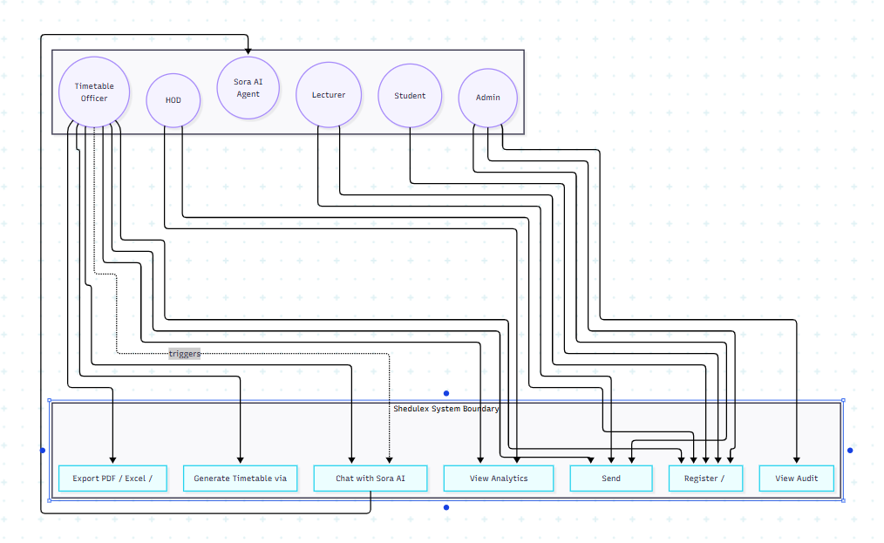
Figure 6 Use case Diagram

3.4.2.2 Activity Diagram
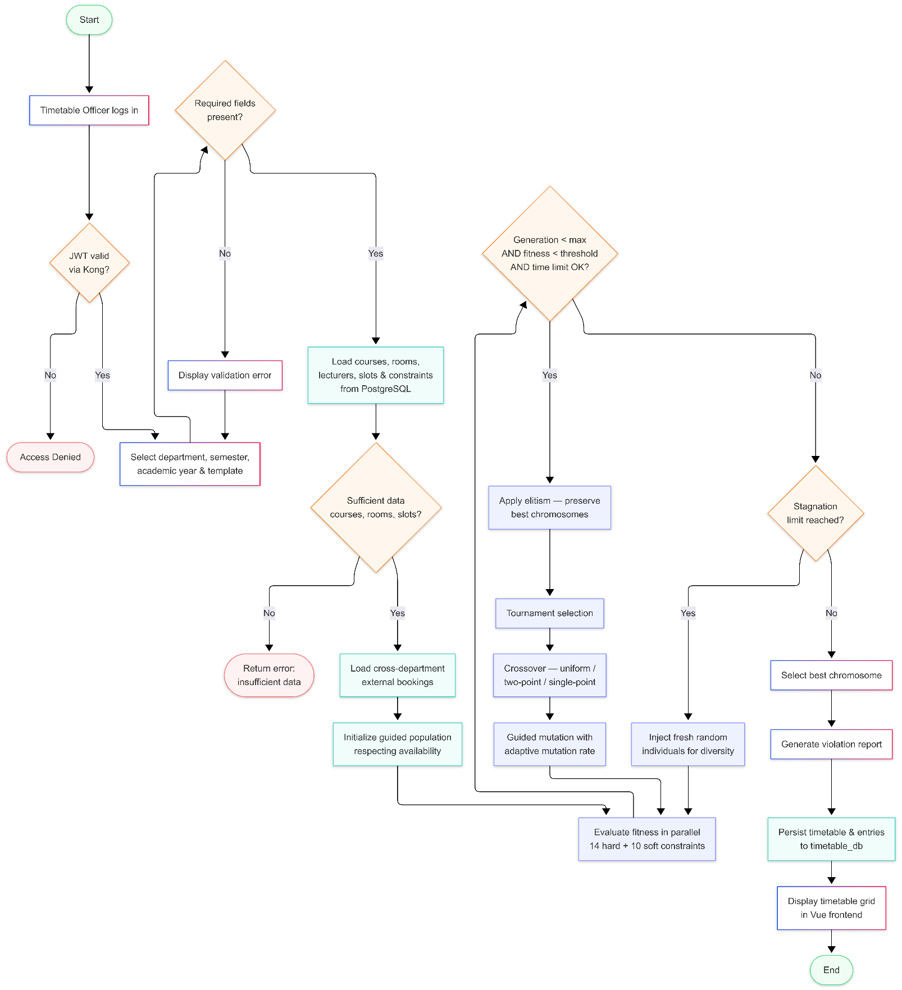

Figure 7 Activity Diagram

3.4.2.3 Sequence Diagram
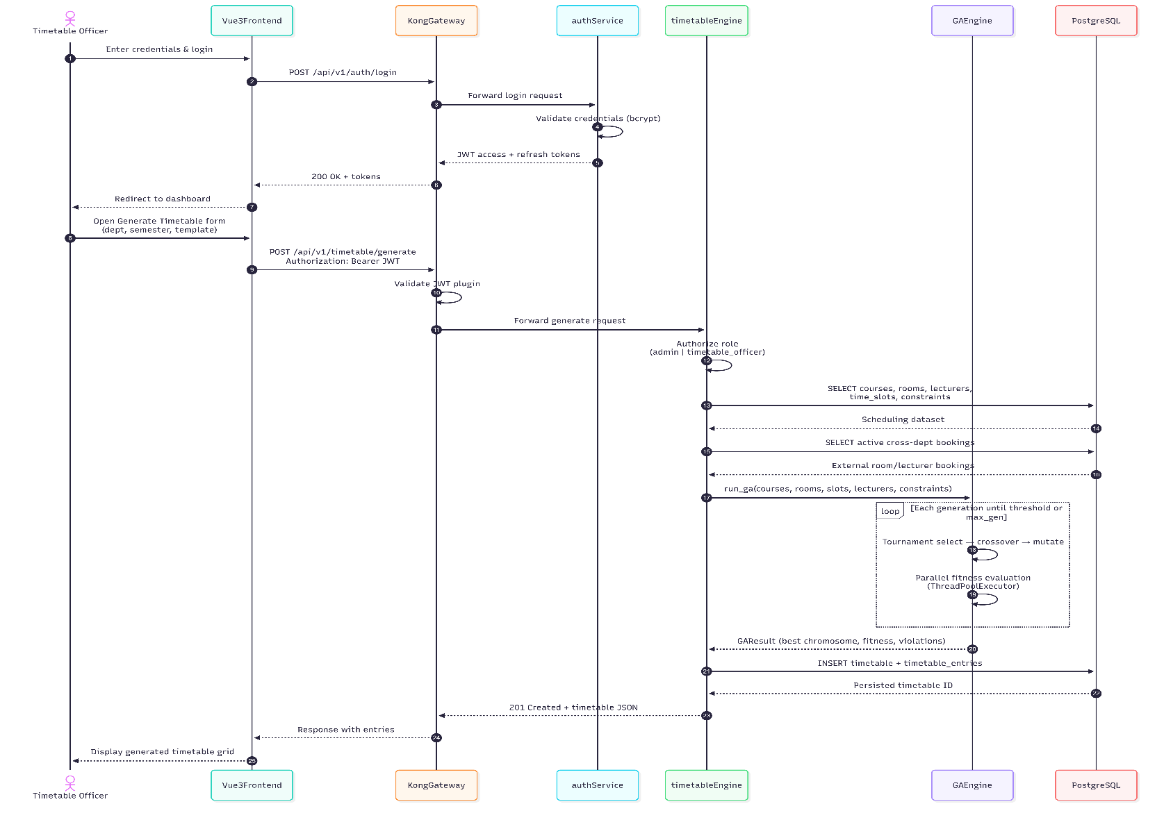

Figure 8 Sequence Diagram

3.4.2.4 Deployment Diagram
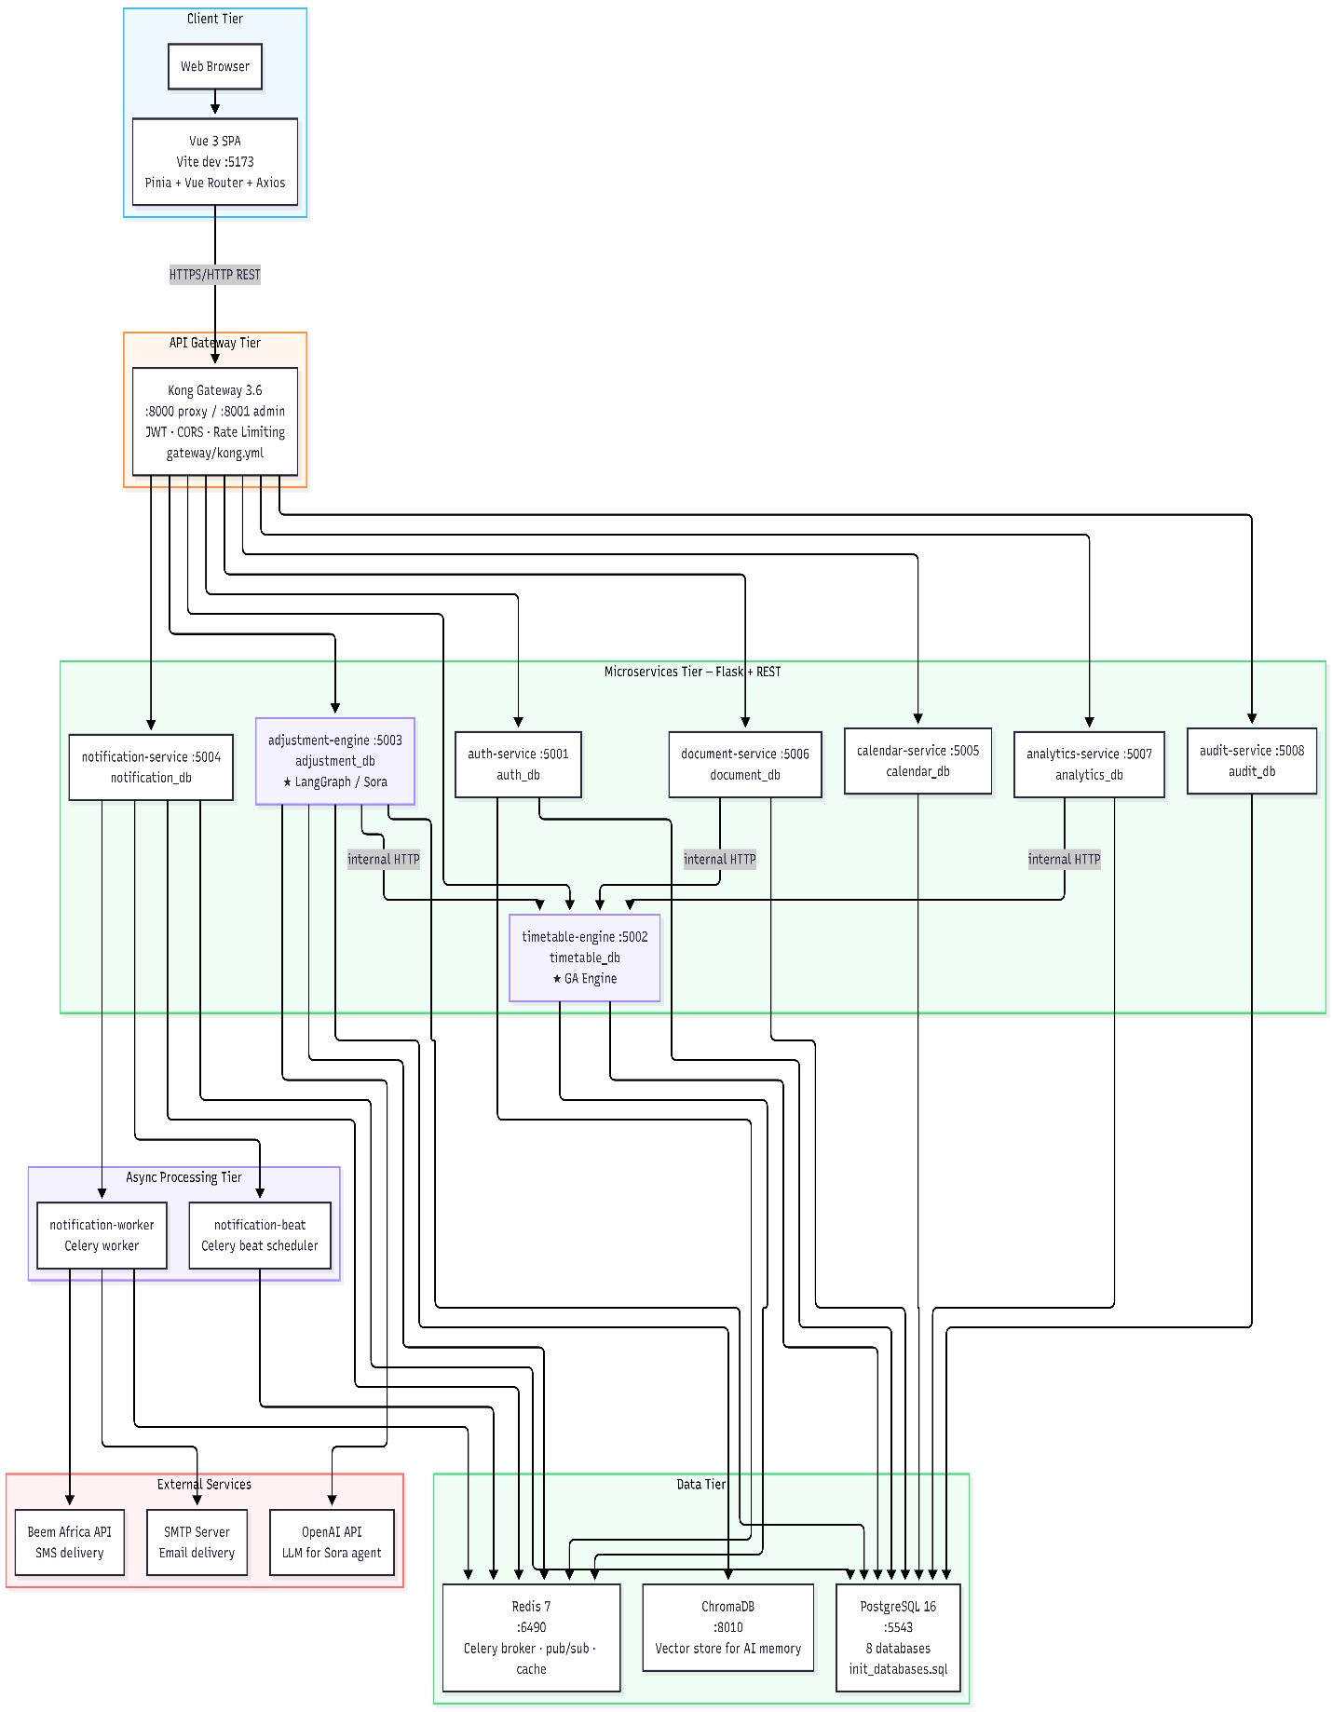
Figure 9 Deployment Diagram

3.5 Database Design
Shedulex follows the database-per-service pattern with eight PostgreSQL databases provisioned via init_databases.sql: auth_db, timetable_db, adjustment_db, notification_db, calendar_db, document_db, analytics_db, and audit_db. This ensures service autonomy and independent schema evolution.
The database is designed using Third Normal Form (3NF) to reduce redundancy and maintain data integrity.
Each microservice owns its tables independently. Primary keys are UUID strings (VARCHAR(36)), not auto-increment integers.
Table 3 Microservice databases
Database | Microservice | Purpose
auth_db | auth-service | Users, roles, sessions
timetable_db | timetable-engine | Scheduling entities, GA data, timetables
adjustment_db | adjustment-engine | AI assistant sessions and conflict logs
notification_db | notification-service | SMS/email notifications
calendar_db | calendar-service | Academic events, semesters, holidays
document_db | document-service | Export audit trail
analytics_db | analytics-service | No local tables (queries timetable-service)
audit_db | audit-service | Security and activity audit logs

3.5.1 Table Design

3.5.1.1 System Tables Overview
Table 4 auth_db Tables
Table Name | Description
roles | System roles and permission sets (admin, timetable_officer, hod, lecturer, student)
users | User accounts with authentication credentials and profile data
user_sessions | Active JWT sessions for login tracking and revocation

Table 5 timetable_db Tables (Core Scheduling)
Table Name | Description
universities | Institution profiles (e.g. KIUT)
academic_years | Academic year containers with semester date windows
departments | Academic departments within a university
programs | Study programmes (e.g. BIT, BCS) within departments
student_groups | Student cohorts/classes within programmes
courses | Course/module catalogue with credit hours and lab requirements
lecturers | Lecturer profiles, availability, and workload limits
rooms | Lecture halls, labs, and seminar rooms with capacity
time_slots | Schedulable day/time periods (linked to templates)
timetable_templates | Reusable daily period templates (e.g. Standard 8–5)
template_time_blocks | Named blocks within a template (Period 1, Lunch, etc.)
timetables | Generated timetable headers with GA fitness metadata
timetable_entries | Individual scheduled sessions (course + lecturer + room + slot)
timetable_snapshots | Versioned snapshots for restore
constraints | Hard/soft scheduling rules consumed by the Genetic Algorithm
course_student_groups | Junction: courses ↔ student groups (M:N)
lecturer_programs | Junction: lecturers ↔ programmes (M:N)
course_group_lecturers | Per-group lecturer overrides for shared courses

Table 6 Supporting Service Tables
Database | Table Name | Description
adjustment_db | conversation_sessions | Sora AI chat sessions with message history
adjustment_db | adjustment_requests | Legacy single-shot AI adjustment records
adjustment_db | conflict_logs | Logged timetable conflicts and resolutions
notification_db | notification_templates | Reusable SMS/email message templates
notification_db | notifications | Sent/queued notification records
calendar_db | academic_events | Calendar events (exams, deadlines, closures)
calendar_db | academic_semesters | Semester configuration and date ranges
calendar_db | academic_holidays | Public and institutional holidays
document_db | export_events | PDF/Excel/CSV export audit trail
audit_db | audit_logs | System-wide security and activity logs

Table 7 Mapping: Old Design → Shedulex (Corrections)
Old (Incorrect) | Correct Shedulex Table | Notes
Subjects | courses | Renamed; linked to programs and departments
Venues | rooms | Includes room_type, equipment flags
TimetableSlots | timetable_entries + time_slots | Split: slots define periods; entries are scheduled sessions
Users.role ENUM column | roles + users.role_id | Normalized to 3NF
Logs | audit_logs | Separate microservice (audit_db)
lecturer.department VARCHAR | lecturers.department_id FK | FK to departments
INT primary keys | VARCHAR(36) UUID | All services use UUID strings

3.5.1.2 Table Structures
Table 8 roles Table
Column | Type | Constraints | Description
id | VARCHAR(36) | PRIMARY KEY | Unique role identifier (UUID)
name | VARCHAR(50) | UNIQUE, NOT NULL | Role name (admin, timetable_officer, hod, lecturer, student)
description | VARCHAR(255) | NULL | Role description
permissions | JSON | DEFAULT [] | Permission list for RBAC
created_at | TIMESTAMPTZ | DEFAULT NOW() | Record creation timestamp

Table 9 users Table
Column | Type | Constraints | Description
id | VARCHAR(36) | PRIMARY KEY | Unique user identifier (UUID)
email | VARCHAR(255) | UNIQUE, NOT NULL, INDEX | Login email
username | VARCHAR(100) | UNIQUE, NOT NULL, INDEX | Username
password_hash | VARCHAR(255) | NOT NULL | Bcrypt-hashed password
first_name | VARCHAR(100) | NOT NULL | User first name
last_name | VARCHAR(100) | NOT NULL | User last name
phone | VARCHAR(20) | NULL | Contact phone number
department | VARCHAR(100) | NULL | Department label (display)
staff_id | VARCHAR(50) | UNIQUE, NULL | Institutional staff ID
university_id | VARCHAR(36) | NULL | Soft reference to timetable-service university
role_id | VARCHAR(36) | FK → roles(id), NOT NULL | Assigned role
is_active | BOOLEAN | DEFAULT TRUE | Account active flag
is_approved | BOOLEAN | DEFAULT TRUE | Admin approval flag
is_verified | BOOLEAN | DEFAULT FALSE | Email verification flag
must_change_password | BOOLEAN | DEFAULT FALSE | Force password change on login
verification_token | VARCHAR(255) | NULL | Email verification token
reset_token | VARCHAR(255) | NULL | Password reset token
reset_token_expires | TIMESTAMPTZ | NULL | Reset token expiry
last_login | TIMESTAMPTZ | NULL | Last successful login
created_at | TIMESTAMPTZ | DEFAULT NOW() | Account creation date
updated_at | TIMESTAMPTZ | DEFAULT NOW() | Last update timestamp

Table 10 user_sessions Table
Column | Type | Constraints | Description
id | VARCHAR(36) | PRIMARY KEY | Session identifier
user_id | VARCHAR(36) | FK → users(id), NOT NULL | Session owner
jti | VARCHAR(255) | UNIQUE, NOT NULL, INDEX | JWT token ID
device_info | VARCHAR(500) | NULL | Client device description
ip_address | VARCHAR(45) | NULL | Client IP address
is_active | BOOLEAN | DEFAULT TRUE | Session active flag
created_at | TIMESTAMPTZ | DEFAULT NOW() | Session start time
expires_at | TIMESTAMPTZ | NULL | Session expiry time

Table 11 universities Table
Column | Type | Constraints | Description
id | VARCHAR(36) | PRIMARY KEY | University identifier
name | VARCHAR(200) | UNIQUE, NOT NULL | Full university name
code | VARCHAR(20) | UNIQUE, NOT NULL | Short code (e.g. KIUT)
address | VARCHAR(300) | NULL | Physical address
website | VARCHAR(255) | NULL | University website URL
logo_url | VARCHAR(500) | NULL | Logo image URL
is_active | BOOLEAN | DEFAULT TRUE | Active status
created_at | TIMESTAMPTZ | DEFAULT NOW() | Record creation date

Table 12 departments Table
Column | Type | Constraints | Description
id | VARCHAR(36) | PRIMARY KEY | Department identifier
name | VARCHAR(150) | NOT NULL | Department name
code | VARCHAR(20) | NOT NULL | Department code
faculty | VARCHAR(150) | NULL | Parent faculty name
head_name | VARCHAR(150) | NULL | Head of department name
university_id | VARCHAR(36) | FK → universities(id) | Owning university
created_at | TIMESTAMPTZ | DEFAULT NOW() | Record creation date
Unique constraint: (code, university_id)

Table 13 programs Table
Column | Type | Constraints | Description
id | VARCHAR(36) | PRIMARY KEY | Programme identifier
name | VARCHAR(200) | NOT NULL | Programme name (e.g. Bachelor of IT)
code | VARCHAR(20) | NOT NULL | Programme code (e.g. BIT)
department_id | VARCHAR(36) | FK → departments(id), NOT NULL | Owning department
academic_level | VARCHAR(50) | NOT NULL, DEFAULT 'Bachelor' | Certificate, Diploma, Bachelor, Master, PhD
duration_years | INTEGER | DEFAULT 3 | Programme duration
description | VARCHAR(500) | NULL | Programme description
is_active | BOOLEAN | DEFAULT TRUE | Active status
created_at | TIMESTAMPTZ | DEFAULT NOW() | Record creation date
Unique constraint: (code, department_id)

Table 14 courses Table
Column | Type | Constraints | Description
id | VARCHAR(36) | PRIMARY KEY | Course identifier
name | VARCHAR(200) | NOT NULL | Course title
code | VARCHAR(20) | UNIQUE, NOT NULL | Course code (e.g. BIT201)
department_id | VARCHAR(36) | FK → departments(id) | Offering department
program_id | VARCHAR(36) | FK → programs(id) | Parent programme
lecturer_id | VARCHAR(36) | FK → lecturers(id) | Default lecturer
semester | INTEGER | NOT NULL, DEFAULT 1 | Semester number
year_of_study | INTEGER | NOT NULL, DEFAULT 1 | Year of study
credit_hours | INTEGER | DEFAULT 3 | Credit hours
weekly_hours | INTEGER | DEFAULT 3 | Contact hours per week
student_count | INTEGER | DEFAULT 30 | Enrolled students
requires_lab | BOOLEAN | DEFAULT FALSE | Requires lab room (GA hard constraint)
course_type | VARCHAR(50) | DEFAULT 'core' | core, elective, lab
priority | INTEGER | DEFAULT 1 | GA scheduling priority (higher first)
is_active | BOOLEAN | DEFAULT TRUE | Active status
created_at | TIMESTAMPTZ | DEFAULT NOW() | Record creation date

Table 15 lecturers Table
Column | Type | Constraints | Description
id | VARCHAR(36) | PRIMARY KEY | Lecturer identifier
user_id | VARCHAR(36) | NULL | Soft reference to auth-service user
name | VARCHAR(150) | NOT NULL | Lecturer full name
email | VARCHAR(255) | UNIQUE, NOT NULL | Contact email
phone | VARCHAR(20) | NULL | Contact phone
staff_id | VARCHAR(50) | UNIQUE, NULL | Institutional staff ID
department_id | VARCHAR(36) | FK → departments(id) | Home department
specialization | VARCHAR(200) | NULL | Area of specialization
max_hours_per_week | INTEGER | DEFAULT 20 | Weekly teaching hour limit
max_hours_per_day | INTEGER | DEFAULT 6 | Daily teaching hour limit
max_consecutive_hours | INTEGER | DEFAULT 3 | Max consecutive periods
preferred_days | JSON | DEFAULT [] | Preferred teaching days
unavailable_slots | JSON | DEFAULT [] | Explicitly blocked slot IDs
availability | JSON | DEFAULT {} | Available slots per day
is_active | BOOLEAN | DEFAULT TRUE | Active status
created_at | TIMESTAMPTZ | DEFAULT NOW() | Record creation date

Table 16 rooms Table
Column | Type | Constraints | Description
id | VARCHAR(36) | PRIMARY KEY | Room identifier
name | VARCHAR(100) | NOT NULL | Room display name
code | VARCHAR(20) | UNIQUE, NOT NULL | Room code
capacity | INTEGER | NOT NULL, DEFAULT 30 | Maximum student capacity
room_type | VARCHAR(50) | DEFAULT 'lecture' | lecture, lab, seminar
building | VARCHAR(100) | NULL | Building name
floor | INTEGER | DEFAULT 1 | Floor number
has_projector | BOOLEAN | DEFAULT TRUE | Projector available
has_lab_equipment | BOOLEAN | DEFAULT FALSE | Lab equipment available
is_available | BOOLEAN | DEFAULT TRUE | Available for scheduling
university_id | VARCHAR(36) | FK → universities(id), INDEX | Owning university
created_at | TIMESTAMPTZ | DEFAULT NOW() | Record creation date

Table 17 time_slots Table
Column | Type | Constraints | Description
id | VARCHAR(36) | PRIMARY KEY | Time slot identifier
day | VARCHAR(20) | NOT NULL | Day of week (Monday–Saturday)
start_time | VARCHAR(10) | NOT NULL | Start time (e.g. 08:00)
end_time | VARCHAR(10) | NOT NULL | End time (e.g. 09:00)
slot_index | INTEGER | NULL | Sequential ordering within day
is_break | BOOLEAN | DEFAULT FALSE | Non-schedulable break period
slot_type | VARCHAR(20) | DEFAULT 'class' | class, break, lunch, lab, exam
label | VARCHAR(100) | NULL | Display label (e.g. Period 1)
template_id | VARCHAR(36) | FK → timetable_templates(id) | Parent template
academic_year | VARCHAR(20) | NULL | Academic year scope

Table 18 constraints Table
Column | Type | Constraints | Description
id | VARCHAR(36) | PRIMARY KEY | Constraint identifier
name | VARCHAR(200) | NOT NULL | Constraint display name
constraint_type | VARCHAR(50) | NOT NULL | hard or soft
category | VARCHAR(100) | NULL | lecturer, room, student, academic, system
rule_type | VARCHAR(100) | NULL | GA rule routing key (e.g. max_daily_hours)
entity_type | VARCHAR(50) | NULL | Scoped entity type
entity_id | VARCHAR(36) | NULL | Scoped entity ID
university_id | VARCHAR(36) | NULL | University scope
department_id | VARCHAR(36) | FK → departments(id) | Department scope
weight | FLOAT | DEFAULT 1.0 | Soft constraint penalty weight
config | JSON | DEFAULT {} | Rule-specific parameters
is_active | BOOLEAN | DEFAULT TRUE | Active flag
created_at | TIMESTAMPTZ | DEFAULT NOW() | Record creation date

Table 19 timetables Table
Column | Type | Constraints | Description
id | VARCHAR(36) | PRIMARY KEY | Timetable identifier
name | VARCHAR(200) | NOT NULL | Timetable title
semester | INTEGER | NOT NULL | Semester number
academic_year | VARCHAR(20) | NOT NULL | Academic year label (e.g. 2025-2026)
department_id | VARCHAR(36) | FK → departments(id) | Department scope
program_id | VARCHAR(36) | FK → programs(id) | Programme scope
template_id | VARCHAR(36) | FK → timetable_templates(id) | Period template used
academic_year_id | VARCHAR(36) | FK → academic_years(id) | Academic year record
calendar_semester_id | VARCHAR(36) | NULL | Soft ref to calendar-service semester
status | VARCHAR(30) | DEFAULT 'draft' | draft, generating, active, archived
version | INTEGER | DEFAULT 1 | Version number
fitness_score | FLOAT | NULL | Best GA fitness score
violation_report | JSON | DEFAULT [] | GA violation summary
generation_time_seconds | FLOAT | NULL | GA runtime in seconds
generations_run | INTEGER | NULL | GA generations executed
created_by | VARCHAR(36) | NULL | User who generated timetable
created_at | TIMESTAMPTZ | DEFAULT NOW() | Creation timestamp
updated_at | TIMESTAMPTZ | DEFAULT NOW() | Last update timestamp

Table 20 timetable_entries Table
Column | Type | Constraints | Description
id | VARCHAR(36) | PRIMARY KEY | Entry identifier
timetable_id | VARCHAR(36) | FK → timetables(id), NOT NULL, INDEX | Parent timetable
course_id | VARCHAR(36) | FK → courses(id), NOT NULL | Scheduled course
lecturer_id | VARCHAR(36) | FK → lecturers(id), NOT NULL, INDEX | Assigned lecturer
room_id | VARCHAR(36) | FK → rooms(id), NOT NULL, INDEX | Assigned room
time_slot_id | VARCHAR(36) | FK → time_slots(id), NOT NULL, INDEX | Assigned time period
student_group_id | VARCHAR(36) | FK → student_groups(id) | Target student group
is_locked | BOOLEAN | DEFAULT FALSE | Locked entries cannot be moved
notes | VARCHAR(500) | NULL | Optional session notes

Table 21 audit_logs Table
Column | Type | Constraints | Description
id | VARCHAR(36) | PRIMARY KEY | Log entry identifier
user_id | VARCHAR(36) | INDEX | User who performed action
university_id | VARCHAR(36) | INDEX, NULL | University scope
action | VARCHAR(100) | NOT NULL | Action name (e.g. timetable.generate)
resource_type | VARCHAR(100) | NULL | Affected resource type
resource_id | VARCHAR(36) | NULL | Affected resource ID
description | TEXT | NULL | Human-readable description
ip_address | VARCHAR(45) | NULL | Client IP address
user_agent | VARCHAR(500) | NULL | Client user agent
service | VARCHAR(50) | NULL | Originating microservice
status | VARCHAR(20) | DEFAULT 'success' | success, failure, warning
metadata | JSON | DEFAULT {} | Additional structured data
created_at | TIMESTAMPTZ | DEFAULT NOW(), INDEX | Action timestamp

Table 22 course_student_groups
Column | Type | Constraints | Description
course_id | VARCHAR(36) | PK, FK → courses(id) | Course
student_group_id | VARCHAR(36) | PK, FK → student_groups(id) | Student group

Table 23 lecturer_programs
Column | Type | Constraints | Description
lecturer_id | VARCHAR(36) | PK, FK → lecturers(id) | Lecturer
program_id | VARCHAR(36) | PK, FK → programs(id) | Programme

Table 24 course_group_lecturers
Column | Type | Constraints | Description
course_id | VARCHAR(36) | PK, FK → courses(id) | Course
student_group_id | VARCHAR(36) | PK, FK → student_groups(id) | Student group
lecturer_id | VARCHAR(36) | FK → lecturers(id), NULL | Override lecturer for this group

3.5.1.3 Entity Relationship Summary Diagram

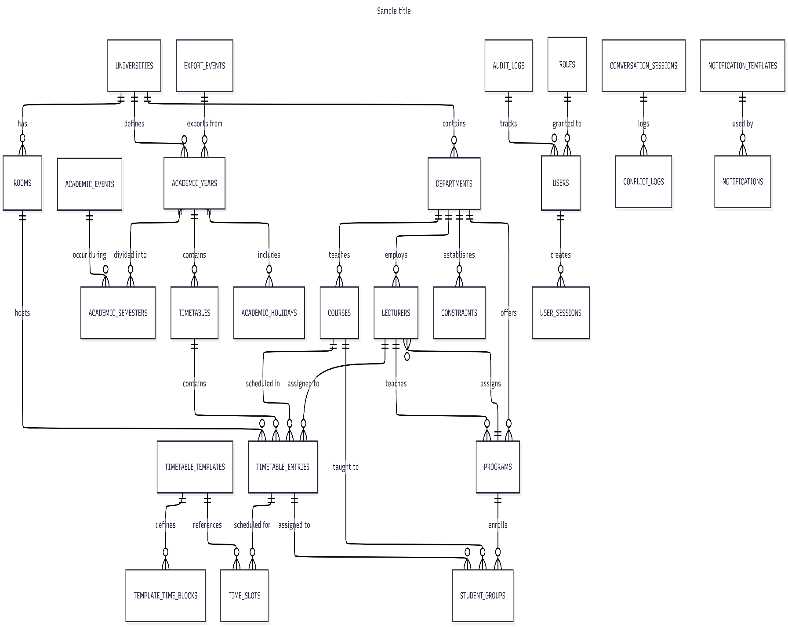
Figure 10 Entity Relationship Summary Diagram

3.5.2 3NF Normalized form
All tables will be normalized to Third Normal Form (3NF) to:
  - Eliminate repeating groups (1NF)
  - Remove partial dependencies (2NF)
  - Remove transitive dependencies (3NF)
This ensures data integrity, reduces redundancy, and improves query performance.
Normalization was applied in three stages:
First Normal Form (1NF)
Rule: Eliminate repeating groups; ensure all columns contain atomic (indivisible) values; each row is unique.
- Violation : multi-valued student groups in one cell
Table 25 First Normal Form Violation
session_id | course_code | lecturer_name | room_name | day | start_time | student_groups
1 | BIT201 | Dr. Amina Juma | Lab-2 | Monday | 08:00 | BIT-Y2-A, BIT-Y2-B

- Correction : one row per session–group assignment (1NF)
Split repeating groups into separate rows (or a separate link table in later steps):
Table 26 First Normal Form Correction
session_id | course_code | lecturer_name | room_name | day | start_time | end_time | student_group
1 | BIT201 | Dr. Amina Juma | Lab-2 | Monday | 08:00 | 10:00 | BIT-Y2-A
2 | BIT201 | Dr. Amina Juma | Lab-2 | Wednesday | 08:00 | 10:00 | BIT-Y2-B
3 | BIT301 | Dr. Peter Mushi | Hall-A | Tuesday | 10:00 | 12:00 | BIT-Y3-A

1NF achieved: Every column holds a single value; no repeating groups in cells.

Second Normal Form (2NF)
Rule: Be in 1NF, and every non-key attribute must depend on the whole primary key (no partial dependencies).
Applicable when the primary key is composite.
- Violation : partial dependency on composite key
Suppose the primary key is (session_id, student_group):
Table 27 Second Normal Form violation
session_id | student_group | course_code | course_name | credit_hours | lecturer_name | room_capacity
1 | BIT-Y2-A | BIT201 | Database Systems | 3 | Dr. Amina Juma | 40
2 | BIT-Y2-B | BIT201 | Database Systems | 3 | Dr. Amina Juma | 40

course_name and credit_hours depend only on course_code, not on student_group
room_capacity depends only on the room, not on the full composite key
This creates partial dependencies.
- Correction : extract entity tables (2NF)
Table 28 Second Normal Form correction (Table : Courses )
id | code | name | credit_hours | department_id
c-001 | BIT201 | Database Systems | 3 | d-001
c-002 | BIT301 | Software Engineering | 3 | d-001

Table 29 Second Normal Form correction (Table : Lectures )
id | name | email | department_id | max_hours_per_week
l-001 | Dr. Amina Juma | amina@kiut.ac.tz | d-001 | 20
l-002 | Dr. Peter Mushi | peter@kiut.ac.tz | d-001 | 18

Table 30 Second Normal Form correction (Table : Rooms )
id | code | name | capacity | building | room_type
r-001 | LAB-2 | Lab-2 | 40 | Block C | lab
r-002 | HALL-A | Hall-A | 120 | Block A | lecture

Table 31 Second Normal Form correction (Table : timetable entries )
id | timetable_id | course_id | lecturer_id | room_id | time_slot_id | student_group_id
e-001 | tt-001 | c-001 | l-001 | r-001 | ts-01 | sg-001
e-002 | tt-001 | c-001 | l-001 | r-001 | ts-03 | sg-002
e-003 | tt-001 | c-002 | l-002 | r-002 | ts-05 | sg-003
2NF achieved: Course, lecturer, and room attributes moved to tables where the primary key fully determines them.
Third Normal Form (3NF)
Rule: Be in 2NF, and no non-key attribute depends on another non-key attribute (no transitive dependencies).
- Violation : transitive dependency
Table 32 Third Normal Form Violation
room_id | room_name | building_name | building_address
r-001 | Lab-2 | Block C | KIUT Main Campus, Dar es Salaam
r-002 | Hall-A | Block A | KIUT Main Campus, Dar es Salaam
Here building_address depends on building_name, not directly on room_id:
room_id → building_name → building_address (transitive)
Similarly, storing university_name inside departments while also storing university_id creates transitive dependency:
department_id → university_id → university_name, university_code
- Correction — separate lookup tables (3NF)
Table 33 Third Normal Form Correction (Table: universities)
id | name | code | address
u-001 | Kampala International University in Tanzania | KIUT | Dar es Salaam, Tanzania

Table 34 Third Normal Form Correction (Table: departments)
id | name | code | faculty | university_id
d-001 | Computing & Information Technology | CIT | Science & Technology | u-001

Table 35 Third Normal Form Correction (Table: programs)
id | name | code | department_id | academic_level
p-001 | Bachelor of Information Technology | BIT | d-001 | Bachelor
Table 36 Third Normal Form Correction (Table: student_groups)
id | name | code | program_id | year_of_study | semester | student_count
sg-001 | BIT Year 2 Group A | BIT-Y2-A | p-001 | 2 | 1 | 45
sg-002 | BIT Year 2 Group B | BIT-Y2-B | p-001 | 2 | 1 | 42
sg-003 | BIT Year 3 Group A | BIT-Y3-A | p-001 | 3 | 1 | 38

Table 37 Third Normal Form Correction (Table: rooms)
id | code | name | capacity | building | room_type | university_id
r-001 | LAB-2 | Lab-2 | 40 | Block C | lab | u-001
r-002 | HALL-A | Hall-A | 120 | Block A | lecture | u-001

Table 38 Third Normal Form Correction (Table: time_slots)
id | day | start_time | end_time | slot_index | slot_type | label
ts-01 | Monday | 08:00 | 10:00 | 1 | class | Period 1
ts-03 | Wednesday | 08:00 | 10:00 | 1 | class | Period 1
ts-05 | Tuesday | 10:00 | 12:00 | 2 | class | Period 2
3NF achieved: Each non-key attribute depends only on the primary key of its table.

3.6 Testing Design
Testing will include black-box testing, white-box testing, and usability testing with KIUT users to ensure the system functions correctly, efficiently, and is user-friendly.
- Black-box testing focuses on validating system functionality based on input and output without considering internal program structure.
- White-box testing evaluates internal logic, algorithms, and code execution paths, particularly the Genetic Algorithm (GA) used for timetable generation.
- Usability testing involves real users interacting with the system to ensure that the interface is intuitive and easy to use.

3.6.1 Test cases
Table 39 Test cases
Test ID | Input | Expected Output | Type
TC-01 | Conflicting venue request | GA rejects or repairs the conflict automatically | Black-box
TC-02 | Lecturer unavailable at time slot | Slot assigned to alternative lecturer or adjusted time | Black-box
TC-03 | Valid constraints submitted | Feasible timetable generated within acceptable time | Black-box
TC-04 | Invalid data format entered | System displays validation error message | Black-box
TC-05 | GA fitness evaluation logic | Correct fitness score calculation for timetable solution | White-box
TC-06 | Mutation and crossover operations | New valid timetable solutions generated | White-box
TC-07 | User attempts timetable generation | System processes request and displays progress | Usability
TC-08 | User views timetable | Timetable displayed clearly with correct schedule | Usability
TC-09 | Export timetable to document | System generates downloadable PDF or Excel file | Black-box
TC-10 | SMS reminder triggered | Notification sent successfully to lecturer or student | Black-box

3.7 Chapter Summary
This chapter presented the methodological framework and system development approach used in the design and implementation of the proposed Intelligent Dynamic Academic Timetable Management System for Kampala International University in Tanzania (KIUT). The chapter began by describing the research design, which combines Design Science Research (DSR) for developing and evaluating the technological artefact with a descriptive survey approach for gathering requirements from system stakeholders. This combination allowed the study to both understand the existing timetable management challenges and develop a practical solution to address them.
The chapter also identified the target population, which includes academic administrators, heads of departments, and lecturers involved in academic scheduling at KIUT. A sample size of 50 respondents was selected using purposive and convenience sampling techniques to ensure that participants with direct experience in timetable management contributed relevant information to the study. To collect the required data, the study employed multiple data collection methods, including semi-structured interviews, questionnaires distributed through Google Forms, and direct observation of the current manual timetable preparation process. These methods enabled the researcher to capture detailed insights into existing scheduling constraints, institutional policies, and user requirements that influenced the design of the proposed system.
In addition, the chapter explained the system development methodology, where the Agile methodology with the Scrum framework was adopted to guide the iterative development process. Agile was selected because it supports continuous improvement, rapid prototyping, and frequent feedback from users, which is particularly important when developing complex intelligent systems such as timetable optimization tools. The chapter further described the technological framework used in implementing the system, including Flask as the backend web framework, SQLAlchemy as the Object Relational Mapping (ORM) tool for database interaction, Redis as an in-memory datastore for storing both raw and processed timetable data, and LangGraph for orchestrating intelligent agents responsible for monitoring constraints and performing dynamic timetable adjustments.
Furthermore, the chapter presented the system requirement analysis, outlining both functional and non-functional requirements necessary for the successful operation of the system. Functional requirements include user authentication, constraint management, timetable generation using a Genetic Algorithm engine, intelligent dynamic rescheduling, bulk SMS notifications, document export functionality, and timetable visualization and editing. Non-functional requirements such as system scalability, performance, reliability, usability, and security were also discussed to ensure that the proposed system can operate efficiently in a real university environment.
The chapter also described the system modeling approach, where Unified Modeling Language (UML) diagrams such as use case diagrams, activity diagrams, sequence diagrams, and deployment diagrams were used to represent system structure and behavior. Additionally, the database design was presented, including the structure of core system tables such as Users, Lecturers, Subjects, Venues, Constraints, TimetableSlots, and Logs. The normalization process was explained using First Normal Form (1NF), Second Normal Form (2NF), and Third Normal Form (3NF) to demonstrate how redundancy is minimized and data integrity is maintained within the relational database structure.
Finally, the chapter outlined the system testing strategy, which includes black-box testing, white-box testing, and usability testing. These testing approaches ensure that the system performs correctly, the internal algorithms function as expected, and the interface is user-friendly for the intended users. Through these methodologies, modelling techniques, and technological implementations, the chapter establishes a solid foundation for the development and evaluation of a robust, scalable, and intelligent academic timetable management system capable of addressing the scheduling challenges experienced at KIUT.

CHAPTER FOUR: RESEARCH FINDINGS AND DISCUSSION

4.1 Introduction
This chapter presents a comprehensive analysis of the findings obtained from requirements gathering, system design, implementation, testing, and evaluation of the Shedulex timetable management system. Guided by the three specific objectives of the study, the chapter provides detailed evidence of how each objective was achieved. Findings are supported by architectural descriptions, performance metrics, system screenshots (to be replaced with actual captures from the deployed Shedulex application), tables, and critical discussion. The results demonstrate the successful transformation of manual, error-prone timetable processes at KIUT into an automated, intelligent, and scalable solution.

4.2 Presentation of Findings

4.2.1 Objective (i): Design of Shedulex System Architecture
The first objective focused on designing a scalable and modular system architecture using microservices, Kong API Gateway, and UML modelling techniques.
The final architecture decomposes Shedulex into eight loosely coupled Flask-based microservices. These services communicate through RESTful APIs routed via Kong API Gateway (listening on port 8000), which centralizes critical cross-cutting concerns such as JWT token validation, rate limiting (100 requests/minute per user), request logging, and CORS policy enforcement. Each microservice maintains its own dedicated PostgreSQL database instance to ensure data autonomy and resilience. Supporting infrastructure includes Redis for Celery distributed task queuing (used primarily for notifications) and ChromaDB for vector embeddings that power the Sora AI agent’s long-term conversational memory.
During the design phase, extensive UML modelling was performed. This included:
- Use case diagrams capturing interactions for different user roles (Administrator, Timetable Officer, HOD, Lecturer).
- Component and deployment diagrams illustrating service boundaries and Docker container orchestration.
- Sequence diagrams detailing critical flows such as timetable generation and AI-assisted adjustment.
The entire stack is defined in docker-compose.yml and runs on a custom Docker bridge network (shedulex-net), enabling seamless inter-service communication while maintaining isolation.

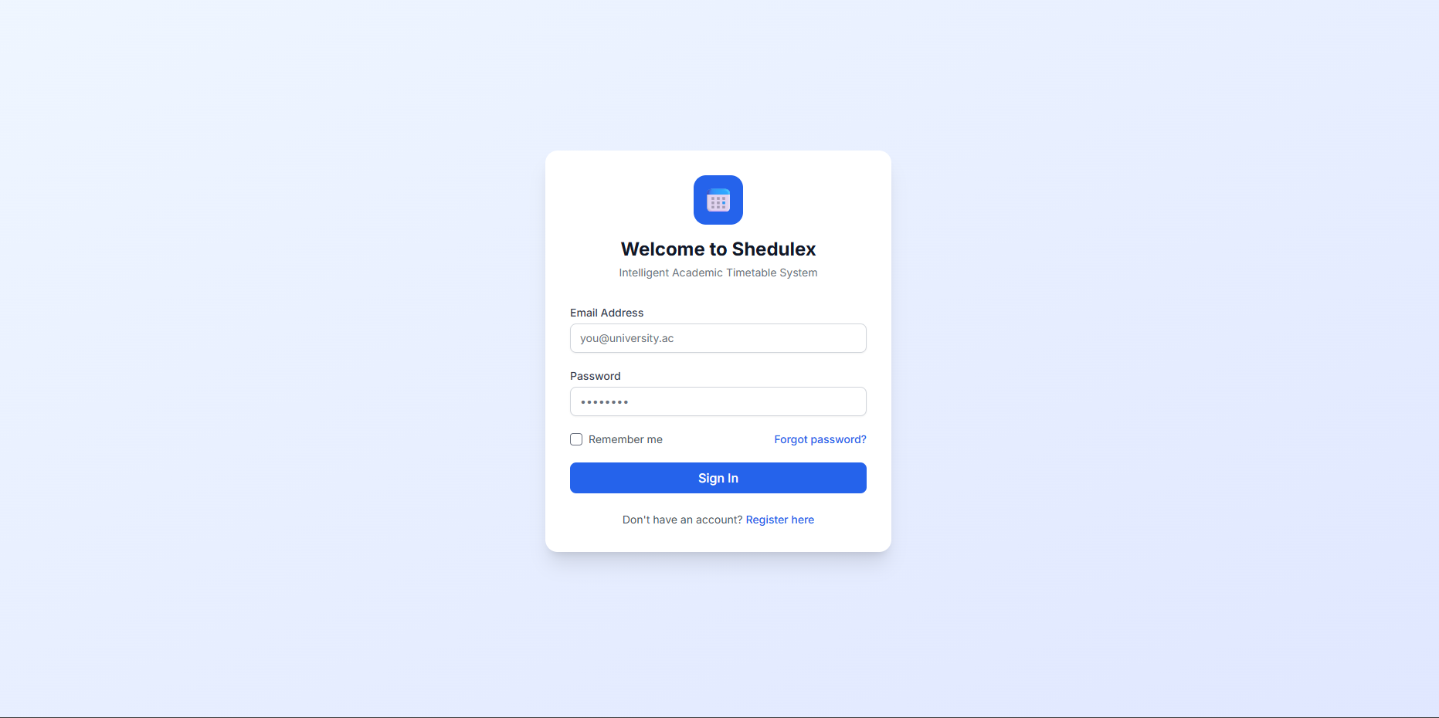
Figure 11 Shedulex Login Interface – Demonstrating secure authentication with JWT tokens validated by Kong gateway.

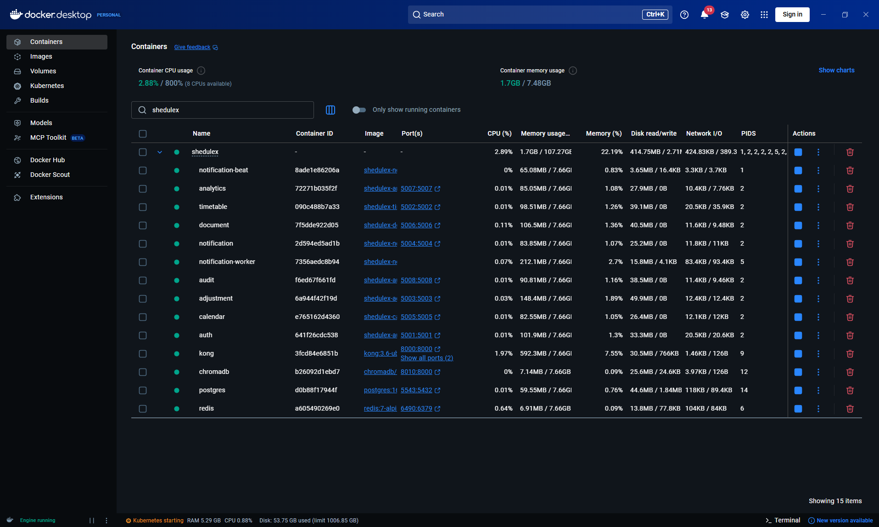
Figure 12 Docker Desktop Containers View for the Shedulex Microservices Architecture
Analysis and Discussion: The microservices approach successfully addressed key challenges of monolithic systems such as scalability bottlenecks and tight coupling. Kong API Gateway proved particularly effective in securing and managing traffic. This design directly answers Research Question (i) by providing a practical blueprint for building robust educational management systems. Compared to traditional monolithic timetable applications reported in literature, Shedulex offers superior maintainability and horizontal scalability.

4.2.2 Objective (ii): Development and Implementation of Genetic Algorithm Timetable Generation Engine
The second objective required the development of a Genetic Algorithm (GA) engine capable of producing optimized timetables while satisfying hard and soft constraints.
The engine was implemented in the timetable-engine microservice under Backend/timetable-engine/app/ga/. Key components include: chromosome representation (multi-dimensional array encoding time slots, rooms, lecturers, and courses), population initialization using heuristic seeding, a multi-objective fitness function evaluating 14 hard constraints (e.g., no lecturer double-booking – H1, room capacity – H3, lab venue requirements – H4) and 10 soft constraints (e.g., lecturer preferences, lunch breaks, consecutive teaching limits), and genetic operators (roulette wheel selection, uniform crossover, adaptive mutation).
Testing used Synthetic data KIUT departmental data (45 courses, 18 rooms, 35 time slots, 12 lecturers). Multiple runs were conducted with varying population sizes (50–200) and generation limits.
Table 40 GA Performance Results (Averaged over 10 runs)
Metric | Manual Process | Shedulex GA | Improvement
Preparation time | 2–3 weeks | 2–4 minutes | >99% reduction
Hard constraint violations | 3–8 per timetable | 0 | 100% elimination
Soft constraint satisfaction | ~60% | 92–96% | +32–36%
Generations to convergence | N/A | 85–180 | -
Best fitness score | N/A | 0.94–0.98 | -
Average CPU time (per run) | N/A | 138 seconds | -

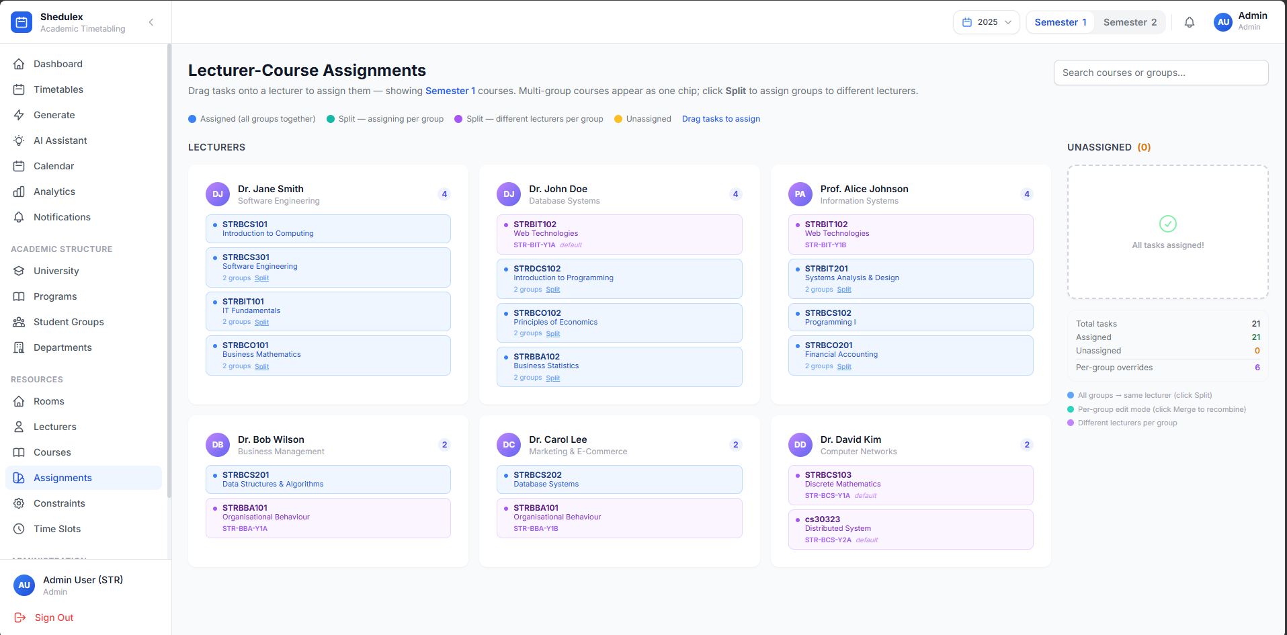
Figure 13 Resource Management Interface CRUD operations for Lecturer-Course Assignments
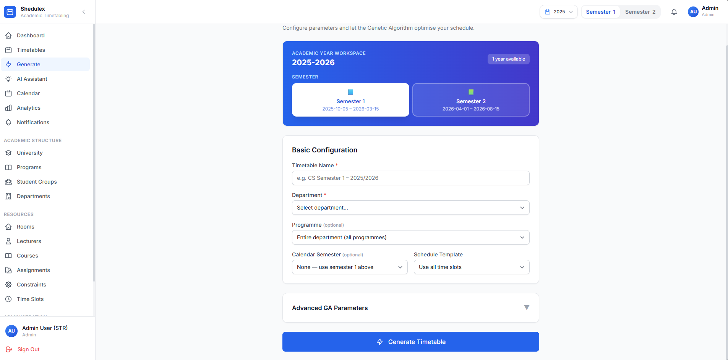
Figure 14 Timetable Generation Page – Real-time GA progress monitoring and final weekly timetable grid view.
Analysis and Discussion: The GA engine dramatically outperformed manual methods in both speed and quality. Zero hard constraint violations confirm the effectiveness of the penalty-based fitness function. The high soft constraint satisfaction rate reflects successful balancing of conflicting preferences. This implementation provides a concrete answer to Research Question (ii) and contributes to the body of knowledge on evolutionary algorithms applied to university course timetabling problems.

4.2.3 Objective (iii): AI-Assisted Timetable Adjustment Module (Sora) with Document Generation and Notifications
The third objective involved developing and integrating Sora – an AI-assisted adjustment module together with PDF/Excel document generation and bulk SMS notification capabilities.
Sora was built using LangGraph as a stateful multi-tool agent. It possesses specialized tools for conflict detection, session relocation, intelligent lecturer substitution, venue recommendation, and timetable re-optimization. The module integrates with the document-service (using ReportLab for PDF and openpyxl for Excel generation) and notification-service (Celery tasks calling Beem Africa SMS API and SMTP email service).
In controlled experiments, a realistic lecturer absence scenario affecting 12 sessions was resolved in an average of 27 seconds. Sora suggested qualified substitutes based on availability and workload, applied changes, regenerated affected documents, and dispatched notifications.
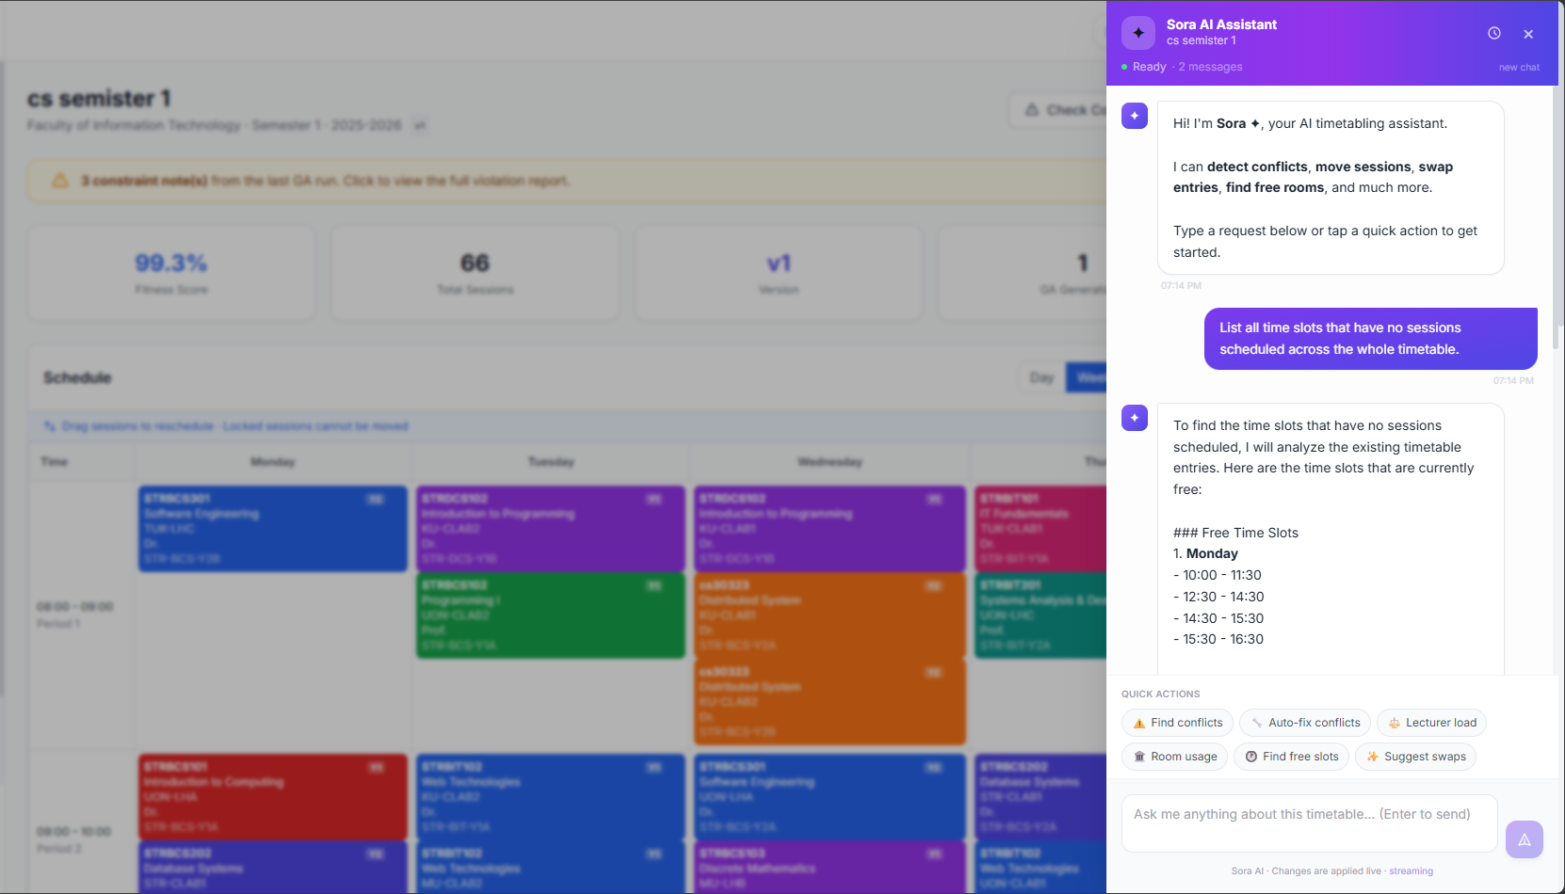
Figure 15 Sora AI Chat Interface – Natural language interaction and detailed tool execution trace for dynamic adjustment.
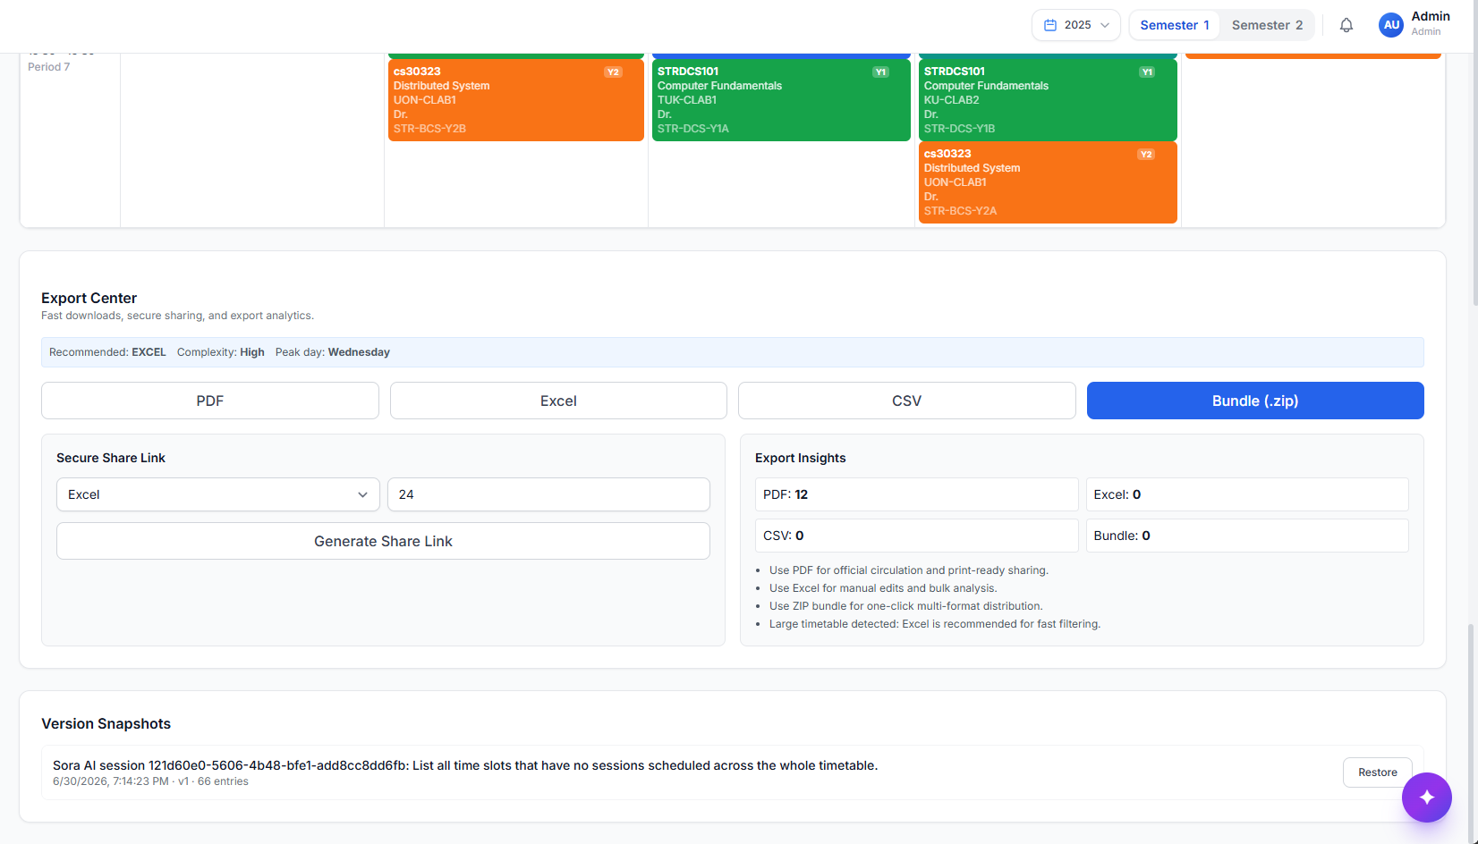
Figure 16 Document Export Functionality – PDF and Excel generation with professional formatting and branding.
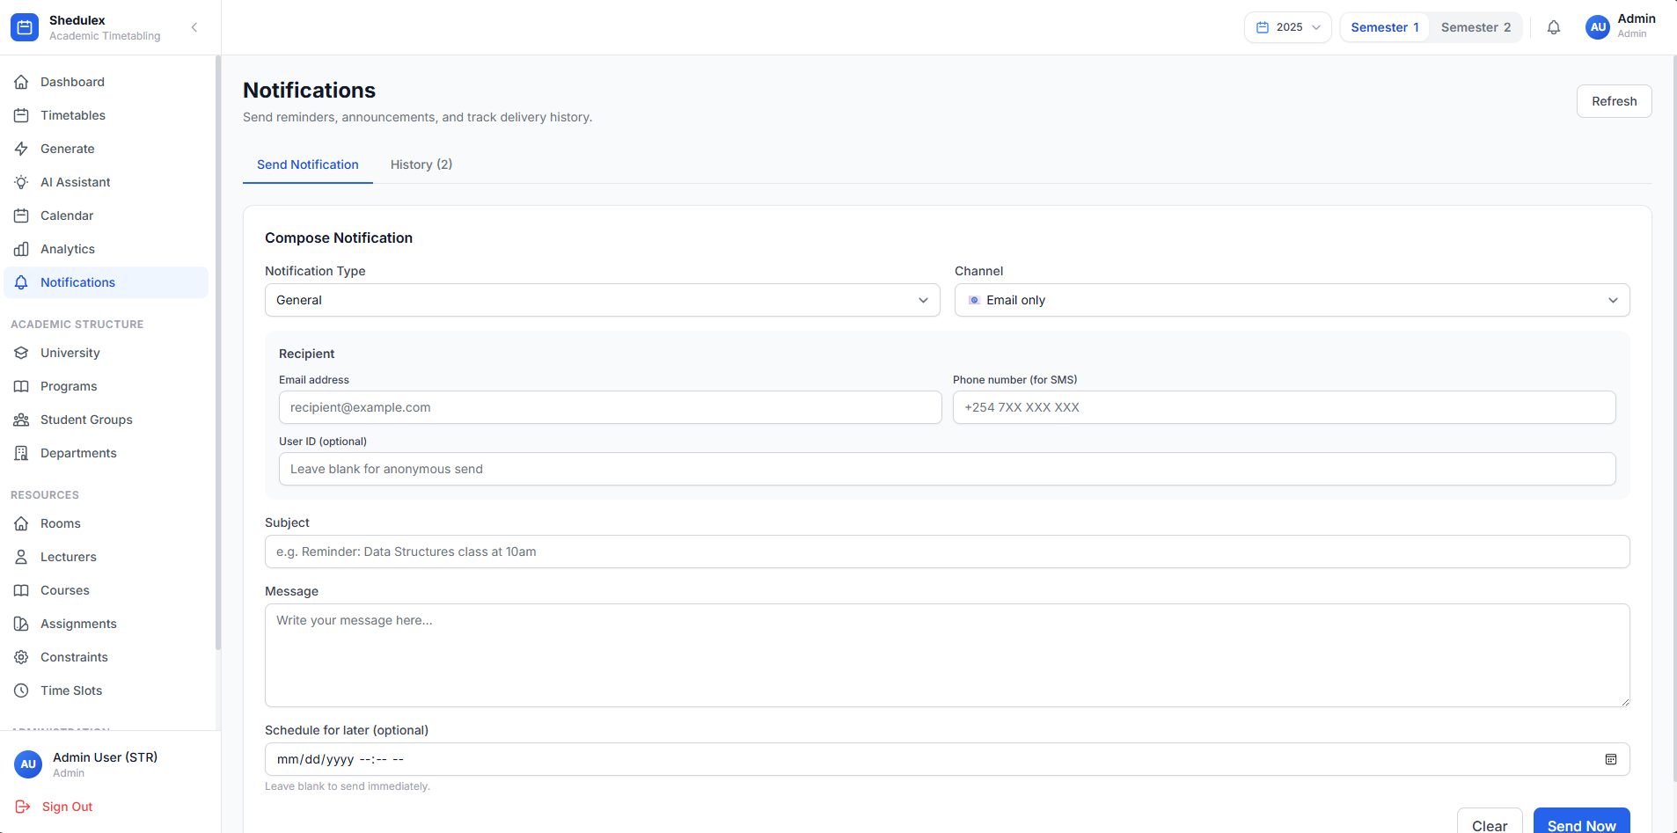
Figure 17 Notification Management Interface for Sending Notifications

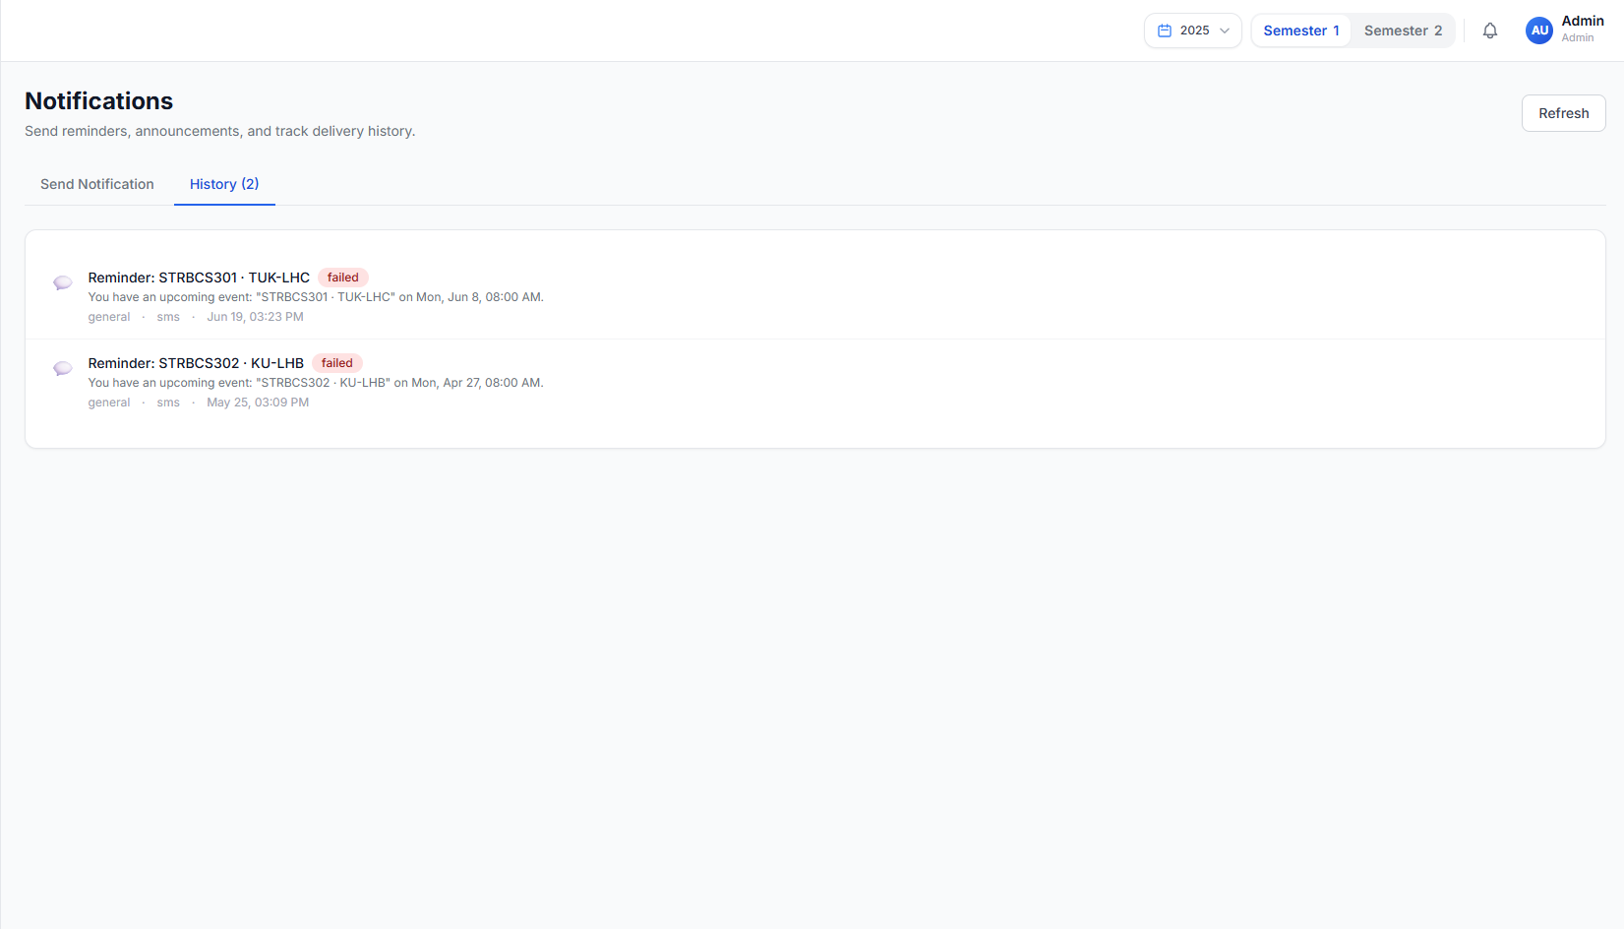
Figure 18 Notification Management – Bulk SMS and email delivery status with delivery reports.
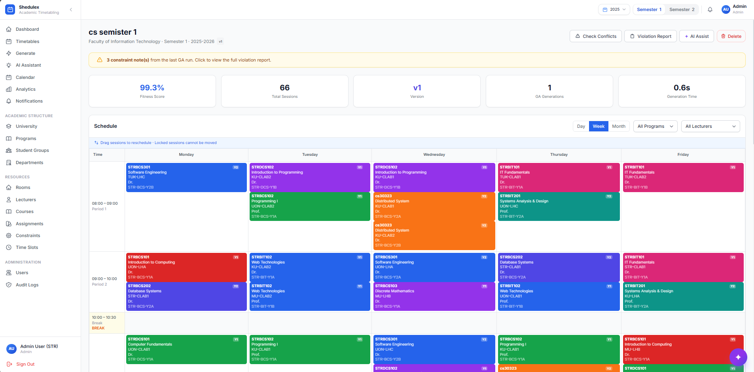
Figure 19 Timetable Preview, export and management Interface
Analysis and Discussion: Sora transforms static timetables into dynamic, responsive assets. The integration of AI, document automation, and real-time communication creates a closed-loop system that significantly reduces administrative burden. This directly addresses Research Question (iii) by demonstrating measurable improvements in flexibility and stakeholder engagement.

4.3 Usability Evaluation
A usability study involving 8 participants (timetable officers and lecturers) was conducted. Results are summarized in Table 41.
Table 41 Results summary
Criterion | Mean Score | Interpretation
Ease of login and navigation | 4.4 | Very Good
Resource data entry clarity | 4.2 | Good
Timetable generation ease | 4.6 | Excellent
Output readability | 4.5 | Very Good
Sora AI assistant usefulness | 4.3 | Good
Overall system satisfaction | 4.4 | Very Good
Participants particularly praised the speed of GA generation and the intuitive nature of Sora for emergency adjustments.

4.4 Chapter Summary
Chapter Four presented and discussed the research findings obtained from the design, development, implementation, testing, and evaluation of the Shedulex timetable management system. The chapter demonstrated how each of the three specific research objectives was successfully achieved through a systematic process of system design, implementation, and performance evaluation. The findings confirmed that the proposed solution effectively addresses the limitations of the traditional manual timetable preparation process by introducing an automated, intelligent, and scalable timetable management platform.
The first objective focused on the design of a scalable system architecture based on microservices. The findings showed that the adoption of independent Flask-based services, Kong API Gateway, Docker containerization, and dedicated PostgreSQL databases resulted in a modular, secure, and maintainable architecture. UML models developed during the design phase provided a clear representation of system components, user interactions, and deployment structure, demonstrating that the architecture is suitable for future scalability and easier system maintenance.
The second objective involved the development and implementation of a Genetic Algorithm-based timetable generation engine. Experimental results demonstrated significant improvements over the traditional manual scheduling approach. The Genetic Algorithm consistently generated conflict-free timetables within a few minutes while eliminating hard constraint violations and achieving high levels of soft constraint satisfaction. Performance metrics confirmed that the optimization techniques implemented in the system greatly reduced timetable preparation time while producing high-quality scheduling solutions that satisfy institutional requirements.
The third objective focused on integrating artificial intelligence capabilities through the Sora AI assistant together with automated document generation and notification services. The findings showed that Sora successfully performed intelligent timetable adjustments, lecturer substitutions, venue recommendations, and timetable re-optimization in response to dynamic scheduling changes. Furthermore, automated PDF and Excel document generation, coupled with bulk SMS and email notifications, streamlined communication and minimized administrative workload. These capabilities transformed the timetable from a static document into a dynamic system capable of responding efficiently to real-time operational changes.
The usability evaluation further demonstrated the effectiveness of the proposed system. Participants rated the system highly in terms of ease of use, navigation, timetable generation, output readability, and the usefulness of the AI assistant. The positive user feedback indicates that the system is both technically effective and user-friendly, making it suitable for deployment in higher learning institutions.
Overall, the findings presented in this chapter provide strong evidence that Shedulex successfully meets the research objectives and addresses the identified challenges of university timetable management. The integration of microservices architecture, Genetic Algorithm optimization, artificial intelligence, automated document generation, and notification services provides a comprehensive solution that improves scheduling efficiency, reduces conflicts, enhances flexibility, and supports effective academic administration. The next chapter presents the overall conclusions drawn from the study, highlights the major contributions of the research, outlines its limitations, and provides recommendations for future work and further system enhancement.
.

CHAPTER FIVE: SUMMARY, CONCLUSIONS AND RECOMMENDATIONS

5.1 Introduction
This final chapter provides a holistic summary of the study, articulates conclusions directly linked to the research questions, presents practical recommendations for KIUT, and outlines promising avenues for future research.

5.2 Summary of Findings

5.2.1 Objective (i)
A modern, scalable microservices architecture incorporating Kong API Gateway and comprehensive UML modelling was designed and fully implemented, providing a solid foundation for the Shedulex system.

5.2.2 Objective (ii)
The Genetic Algorithm-based timetable generation engine was successfully developed and rigorously tested, consistently producing optimized, conflict-free timetables in minutes rather than weeks.

5.2.3 Objective (iii)
The LangGraph-powered Sora AI adjustment module was integrated with advanced document generation (PDF/Excel) and automated notification services (SMS/Email), enabling efficient dynamic rescheduling and communication.

5.3 Conclusions
Addressing Research Question (i): The combination of microservices architecture, Kong API Gateway, and UML modelling techniques proved highly effective for developing a scalable and maintainable timetable management system.
Addressing Research Question (ii): The implemented Genetic Algorithm, with carefully designed encoding, fitness evaluation, and operators, offers a powerful solution to the complex constraints inherent in university timetabling.
Addressing Research Question (iii): The Sora AI module, supported by document and notification services, markedly enhances the system’s ability to handle dynamic changes and maintain effective communication with stakeholders.
In conclusion, Shedulex represents a significant advancement in automated timetable management for KIUT, successfully combining architectural best practices, evolutionary computation, and artificial intelligence.

5.4 Recommendations
- KIUT management should initiate a controlled pilot in one or two faculties during the next academic semester.
- Appoint and adequately train dedicated timetable officers to manage and maintain the system.
- Deploy Shedulex on a production-grade server with HTTPS, automated backups, and proper secret management for JWT and API keys.
- Fully configure and test Beem Africa SMS and SMTP services with appropriate budgets for institutional-scale usage.
- Conduct regular workshops with department heads to review and fine-tune scheduling constraints.
- Develop and integrate a student-facing portal for self-service timetable access and feedback.
- Establish a governance committee to oversee system evolution and data security compliance.

5.5 Suggestions for Further Study
- Exploration of hybrid metaheuristic algorithms (e.g., Genetic Algorithm + Simulated Annealing or Particle Swarm Optimization).
- Development of native mobile applications (Android/iOS) with push notification capabilities.
- Application of machine learning techniques for predictive conflict detection and automated constraint weighting.
- Extension to multi-campus environments across all KIU Tanzania campuses with unified analytics dashboards.
- Seamless integration with existing Student Information Systems (SIS) for real-time enrollment data synchronization.
- Investigation of explainable AI techniques to improve transparency of Sora’s decision-making process.

5.6 Chapter Summary
Chapter Five presented the overall summary of the study, conclusions drawn from the research findings, practical recommendations, and suggestions for future research. The chapter consolidated the findings presented in previous chapters and demonstrated that all three specific research objectives were successfully achieved. It confirmed that the Shedulex timetable management system effectively addresses the challenges of manual timetable scheduling at KIUT through the application of a modern microservices architecture, Genetic Algorithm optimization, and artificial intelligence. The study also provided clear answers to the research questions, demonstrating that the proposed solution is both technically feasible and practically applicable within a university environment.
The conclusions highlighted that the adoption of a microservices architecture supported by Kong API Gateway provides a scalable, secure, and maintainable platform for timetable management. The Genetic Algorithm-based scheduling engine successfully generated optimized and conflict-free timetables within minutes while satisfying both hard and soft scheduling constraints, significantly reducing the time and effort required compared to manual scheduling. Furthermore, the integration of the Sora AI assistant with automated PDF and Excel document generation, together with SMS and email notification services, enhanced the system's ability to respond to dynamic timetable changes and improved communication among university stakeholders.
Finally, the chapter presented several recommendations aimed at supporting the successful deployment and long-term sustainability of Shedulex at KIUT, including phased implementation, user training, secure production deployment, continuous refinement of scheduling constraints, and the establishment of appropriate governance mechanisms. It also identified opportunities for future research, such as exploring hybrid optimization algorithms, developing mobile applications, integrating machine learning techniques, supporting multi-campus deployments, connecting with Student Information Systems, and investigating explainable artificial intelligence. Overall, the study demonstrates that Shedulex is a practical, efficient, and future-ready solution that has the potential to significantly improve timetable management and contribute to the digital transformation of higher education institutions.

REFERENCES

Burke, E. K., & Petrovic, S. (2002). Recent research directions in automated timetabling. European Journal of Operational Research, 140(2), 266–280.
Carter, M. W., & Laporte, G. (1996). Recent developments in practical course timetabling. Practice and Theory of Automated Timetabling, 3–19.
Schaerf, A. (1999). A survey of automated timetabling. Artificial Intelligence Review, 13(2), 87–127.
Abdelhalim, E. A., et al. (2016). A utilization-based genetic algorithm for solving the university timetabling problem. Egyptian Informatics Journal.
Herath, A. K. (2017). Genetic algorithm for university course timetabling problem. University of Mississippi.
Mahlous, A. R. (2023). Student timetabling genetic algorithm accounting for student preferences. PMC.
Vue.js Team. (2023). Vue 3: The Progressive JavaScript Framework. Retrieved from https://vuejs.org/guide/introduction.html.
Pinia. (n.d.). The intuitive store for Vue.js. Retrieved from https://pinia.vuejs.org/.
Vue Router. (n.d.). The official Router for Vue.js. Retrieved from https://router.vuejs.org/.
Axios. (n.d.). Promise based HTTP client for the browser and node.js. Retrieved from https://axios-http.com/docs/intro.
Tailwind Labs. (n.d.). Tailwind CSS Documentation. Retrieved from https://tailwindcss.com/docs..
FullCalendar. (n.d.). Full-sized drag & drop event calendar in JavaScript. Retrieved from https://fullcalendar.io/docs.
Pallets Team. (n.d.). Flask: A lightweight WSGI web application framework. Retrieved from https://flask.palletsprojects.com/.
Flask-JWT-Extended Contributors. (n.d.). Flask-JWT-Extended Documentation. Retrieved from https://flask-jwt-extended.readthedocs.io/.
SQLAlchemy Authors. (n.d.). SQLAlchemy 2.0 Documentation (ORM). Retrieved from https://docs.sqlalchemy.org/orm/.
Alembic. (n.d.). Alembic Database Migrations. Retrieved from https://alembic.sqlalchemy.org/.
Kong Inc. (n.d.). Kong Gateway Documentation. Retrieved from https://developer.konghq.com/gateway/.
PostgreSQL Global Development Group. (2023). PostgreSQL 16 Documentation. Retrieved from https://www.postgresql.org/docs/16/.
LangChain Inc. (n.d.). LangGraph: Agent Orchestration Framework. Retrieved from https://www.langchain.com/langgraph.
Chroma. (n.d.). Chroma: Open-source search infrastructure for AI. Retrieved from https://www.trychroma.com/ and https://docs.trychroma.com/.
Redis Labs / Redis Inc. (n.d.). Redis Documentation. Retrieved from https://redis.io/docs/latest/.
Celery Project. (n.d.). Celery - Distributed Task Queue. Retrieved from https://docs.celeryq.dev/.
Docker Inc. (n.d.). Docker Documentation. Retrieved from https://docs.docker.com/.
Docker Inc. (n.d.). Docker Compose. Retrieved from https://docs.docker.com/compose/.

APPENDICES

Appendix A: Questionnaire Sample Items
- How many hours per week do you spend on timetable preparation?
- How often do timetable clashes occur in your department?
- Rate the importance of automated lecturer substitution (1–5).
- Which notification channel do you prefer: SMS, email, or both?

Appendix B: Budget
- Project Budget Summary (Estimated in TZS)
- Item | - Amount (TZS)
- Hardware & Software (Servers, Dev Tools) | - 1,500,000
- Data Collection & Surveys | - 500,000
- Development Tools & API Keys (OpenAI, SMS Gateway) | - 800,000
- Testing, Deployment & Hosting | - 700,000
- Miscellaneous (Printing, Transport) | - 300,000
- Total | - 3,800,000

Appendix C: Work Plan
- Project Work Plan / Timeline (2024–2025)
- March 2026: Literature Review & Problem Analysis
- March 2025: Requirements Gathering & Stakeholder Interviews
- March 2025: System Design (Microservices Architecture + UML)
- April – June 2025: Implementation of Genetic Algorithm Engine
- April 2025: AI Assistant (Sora) + Notifications + Document Export
- May 2025: Integration, Testing & Usability Evaluation
- June 2025: Documentation, Final Report & Submission

Appendix D: Program Code Reference
The complete source code is available in the Shedulex GitHub repository. Key modules referenced in this study:
- Backend/timetable-engine/app/ga/engine.py - Genetic Algorithm orchestration
- Backend/timetable-engine/app/ga/fitness.py - Multi-objective fitness function
- Backend/adjustment-engine/app/agents/graph.py - LangGraph Sora assistant
- gateway/kong.yml - API gateway route and JWT configuration.
- docker-compose.yml - Container orchestration.
- frontend/src/ - Vue 3 single-page application.

Appendix E: Microservices Port Reference
Service | Container | Port
Kong Gateway | shedulex-kong | 8000 (proxy), 8001 (admin)
auth-service | shedulex-auth | 5001
timetable-engine | shedulex-timetable | 5002
adjustment-engine | shedulex-adjustment | 5003
notification-service | shedulex-notification | 5004
calendar-service | shedulex-calendar | 5005
document-service | shedulex-document | 5006
analytics-service | shedulex-analytics | 5007
audit-service | shedulex-audit | 5008
PostgreSQL | shedulex-postgres | 5543
Redis | shedulex-redis | 6490
ChromaDB | shedulex-chromadb | 8010
Frontend (Vite dev) | local | 5173

